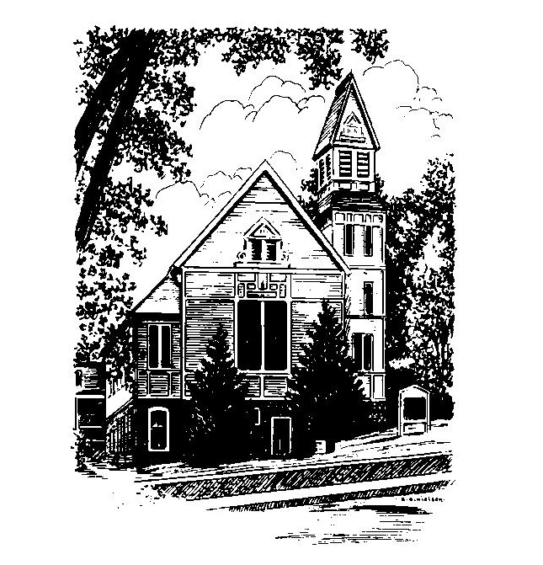
To Contact Us:
Church Office: 978-939-8821
Church website: www.baldwinvillecongochurch.org
Organist: Michelle Salvanelli
Videographer: Jeff Salvanelli
Church Wi-Fi password: Memorial 1874

Deacon of the Day: Joanne Francis
Liturgist: Nowell Francis
Our current supply preacher is Rev. Mike Scott.

Today: As this is Mother’s Day, there will be no coffee hour.

*denotes “All who are able please stand”. Masking is optional

Meditation Thought

“As I see it . . . God acts in history and in your and my brief histories not as the puppeteer who sets the scene and works the strings but rather as the great director who no matter what role fate casts us in conveys to us somehow from the wings, if we have our eyes, ears, hearts open and sometimes even if we don't, how we can play those roles in a way to enrich and ennoble and hallow the whole vast drama of things including our own small but crucial parts in it.”
― Frederick Buechner, Originally published in Telling Secrets

MEMORIAL CONGREGATIONAL CHURCH U.C.C. BALDWINVILLE, MA.
An Open and Affirming Church of
the United Church of Christ

May 12, 2024

No Matter Who You Are, No Matter Where
You Are on Life’s Journey; You Are Welcome Here!

PRELUDE

WELCOME

CALL TO WORSHIP

Leader: Sisters and brothers, we have come
together to worship the One who offers us
freedom and grace.
People: For the Spirit has set us free to be the
people we were intended to be.
Leader: Let our worship be a celebration of the
joyful unity we find in the liberating power
of the Spirit.
People: Let us worship in spirit and in truth!

*HYMN This Is My Father's World Red Hymnal #59

*UNISON PRAYER OF INVOCATION

Lord of our life, we rejoice in your love which renews us each day and calls us to share in abundant life. We are thankful for Jesus who revealed most fully your loving purpose for all people. We celebrate your Spirit of Holiness that draws all humanity into your circle of love. Make us open to your presence in our lives and in our worship, we pray, that we might truly reflect your love in all we say and do. Amen.

*SHARING THE PEACE OF CHRIST
One: May the peace of Christ be with you!
Many: And also with you!
--Please “Pass the Peace” however you feel comfortable
as we sing Amen!
*AMEN (Sung twice) Red Hymnal #317
Amen, Amen, Amen, Amen, Amen

OFFERING OURSELVES AND OUR GIFTS

CALL TO GIVING

As our offering is brought forward let us sing:
Praise God, from whom all blessings flow;
Praise God, all creatures here below;
Alleluia! Alleluia!
Praise God above, you heavenly host;
Praise Father, Son, and Holy Ghost.
Alleluia! Alleluia! Alleluia!
Alleluia! Alleluia!

PRAYER OF DEDICATION

FIRST SCRIPTURE READING Psalm 1

SPECIAL MUSIC

SECOND SCRIPTURE READING Acts 1:15-17, 21-26

MESSAGE A Roll of the Dice:
On Grace, Providence, Luck, and Serendipity
Mike Scott

*HYMN On Eagle's Wings Red Hymnal #77

SHARING OUR PRAYERS, OUR JOYS, OUR HOPES

PASTORAL PRAYER

THE LORD’S PRAYER

Our father who art in heaven hallowed be thy name. Thy kingdom come thy will be done on earth as it is in heaven. Give us this day our daily bread and forgive us our trespasses as we forgive those who trespass against us. And lead us not into temptation but deliver us from evil. For thine is the kingdom and the power and the glory forever. Amen.
-Response (singing)
Hear our Prayer, O Lord, Hear our prayer O Lord.
Incline thine ear to us, and grant us thy peace. Amen

*HYMN: Amazing Grace Red Hymnal #546

*BENEDICTION

POSTLUDE

