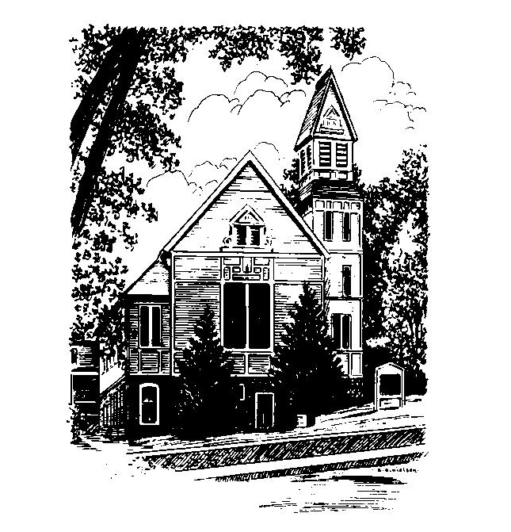
To Contact Us:
Church Office: 978-939-8821
Church website: www.baldwinvillecongochurch.org
Organist: Michelle Salvanelli
Videographer: Jeff Salvanelli
Church Wi-Fi password: Memorial 1874

Deacon of the Month: Barbara Woodbury
Liturgist: Barbara Woodbury
Our current supply preacher is Rev. Mike Scott.
Today: Coffee and conversation downstairs

*denotes “All who are able please stand”. Masking is optional

Meditation Thought
(One worth repeating)

“The time is ripe for looking back over the day, the week, the year, and trying to figure out where we have come from and where we are going to, for sifting through the things we have done and the things we have left undone for a clue to who we are and who, for better or worse, we are becoming. But again and again we avoid the long thoughts….We cling to the present out of wariness of the past. And why not, after all? We get confused. We need such escape as we can find. But there is a deeper need yet, I think, and that is the need—not all the time, surely, but from time to time—to enter that still room within us all where the past lives on as a part of the present, where the dead are alive again, where we are most alive ourselves to turnings and to where our journeys have brought us. The name of the room is Remember—the room where with patience, with charity, with quietness of heart, we remember consciously to remember the lives we have lived.”
― Frederick Buechner, From A Room Called Remember

MEMORIAL CONGREGATIONAL CHURCH U.C.C. BALDWINVILLE, MA.
An Open and Affirming Church of
the United Church of Christ

April 28, 2024

No Matter Who You Are, No Matter Where
You Are on Life’s Journey; You Are Welcome Here!

PRELUDE

WELCOME

CALL TO WORSHIP

Leader: May the Word of good news open
our hearts
People: that we may listen and hear,
Leader: open our minds,
People: that we may appreciate and
understand how blessed we are to join
hands here and touch holiness!

*HYMN I Love Your Church, O God
Red Hymnal #274

*UNISON PRAYER OF INVOCATION

Deliver us, O Lord of Hosts, from a lack of concern, from love of ease, from the need for power. Deliver us from too narrow a view, from too little to love, from intolerance to change. Deliver us from every kind of bondage, that we may find our freedom in you. Amen.

*SHARING THE PEACE OF CHRIST
One: May the peace of Christ be with you!
Many: And also with you!
--Please “Pass the Peace” however you feel comfortable
as we sing Amen!
*AMEN (Sung twice) Red Hymnal #317
Amen, Amen, Amen, Amen, Amen

OFFERING OURSELVES AND OUR GIFTS

CALL TO GIVING

As our offering is brought forward let us sing:
Praise God, from whom all blessings flow;
Praise God, all creatures here below;
Alleluia! Alleluia!
Praise God above, you heavenly host;
Praise Father, Son, and Holy Ghost.
Alleluia! Alleluia! Alleluia!
Alleluia! Alleluia!

PRAYER OF DEDICATION

FIRST SCRIPTURE READING Psalm 22:19-31

SPECIAL MUSIC

SECOND SCRIPTURE READING 1 John 4:7-21

MESSAGE "To a People Yet Unborn"
Mike Scott

*HYMN I Would Be True Red Hymnal #608

SHARING OUR PRAYERS, OUR JOYS, OUR HOPES

PASTORAL PRAYER

THE LORD’S PRAYER

Our father who art in heaven hallowed be thy name. Thy kingdom come thy will be done on earth as it is in heaven. Give us this day our daily bread and forgive us our trespasses as we forgive those who trespass against us. And lead us not into temptation but deliver us from evil. For thine is the kingdom and the power and the glory forever. Amen.
-Response (singing)
Hear our Prayer, O Lord, Hear our prayer O Lord.
Incline thine ear to us, and grant us thy peace. Amen

*HYMN: Take My Life Red Hymnal #609

*BENEDICTION

POSTLUDE

