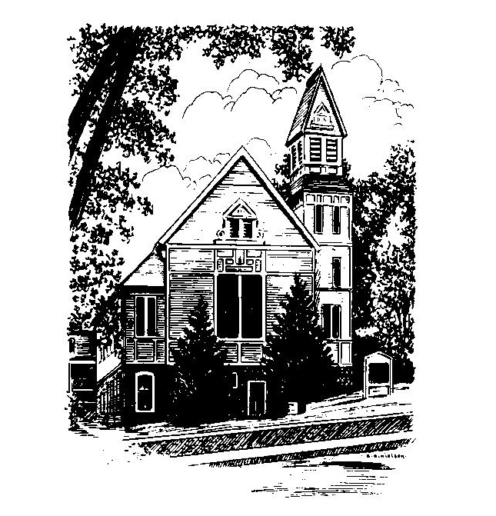
To Contact Us:
Church Office: 978-939-8821
Church website: www.baldwinvillecongochurch.org
Organist: Michelle Salvanelli
Videographer: Jeff Salvanelli
Church Wi-Fi password: Memorial 1874

Deacon of the Month: Barbara Woodbury
Liturgist: Linda Bevan
Our current supply preacher is Rev. Mike Scott.
Today: Coffee and conversation downstairs

*denotes “All who are able please stand”. Masking is optional

Meditation Thought
(One worth repeating)

The love for equals is a human thing—of friend for friend, brother for brother. It is to love what is loving and lovely. The world smiles.
The love for the less fortunate is a beautiful thing—the love for those who suffer, for those who are poor, the sick, the failures, the unlovely. This is compassion, and it touches the heart of the world.
The love for the more fortunate is a rare thing—to love those who succeed where we fail, to rejoice without envy with those who rejoice, the love of the poor for the rich, of the black man for the white man. The world is always bewildered by its saints.
And then there is the love for the enemy—love for the one who does not love you but mocks, threatens, and inflicts pain. The tortured's love for the torturer. This is God's love. It conquers the world.
Frederich Buechner

-Originally published in The Magnificent Defeat

MEMORIAL CONGREGATIONAL CHURCH U.C.C. BALDWINVILLE, MA.
An Open and Affirming Church of
the United Church of Christ

April 21, 2024

No Matter Who You Are, No Matter Where
You Are on Life’s Journey; You Are Welcome Here!

PRELUDE

WELCOME

CALL TO WORSHIP

Leader: Rejoice for the Spirit is among us.
People: Give thanks, for in Christ we are new
people.
Leader: Sing praise for we have come to worship the
Lord of Life.
People: Let our voices ring out in song!

*HYMN A Mighty Fortress Is Our God
Red Hymnal #65

*UNISON PRAYER OF INVOCATION

Bounteous Heart of All Being, bless us with your Spirit of Holiness as we gather before you. Pour out your love upon us and shower us with your grace. As we turn to you, we pray that you will fill our hearts with kindness, faithfulness, gentleness, and self-control. And so, strengthened in faith, may we share your generosity and love with all the world. Amen.

*SHARING THE PEACE OF CHRIST
One: May the peace of Christ be with you!
Many: And also with you!
--Please “Pass the Peace” however you feel comfortable
as we sing Amen!
*AMEN (Sung twice) Red Hymnal #317
Amen, Amen, Amen, Amen, Amen

OFFERING OURSELVES AND OUR GIFTS

CALL TO GIVING

As our offering is brought forward let us sing:
Praise God, from whom all blessings flow;
Praise God, all creatures here below;
Alleluia! Alleluia!
Praise God above, you heavenly host;
Praise Father, Son, and Holy Ghost.
Alleluia! Alleluia! Alleluia!
Alleluia! Alleluia!

PRAYER OF DEDICATION

FIRST SCRIPTURE READING Psalm 23

SPECIAL MUSIC

GOSPEL READING John 10:11-18

MESSAGE “In the Presence of My Enemies”
Mike Scott

*HYMN God Is My shepherd Red Hymnal #79

SHARING OUR PRAYERS, OUR JOYS, OUR HOPES

PASTORAL PRAYER

THE LORD’S PRAYER

Our father who art in heaven hallowed be thy name. Thy kingdom come thy will be done on earth as it is in heaven. Give us this day our daily bread and forgive us our trespasses as we forgive those who trespass against us. And lead us not into temptation but deliver us from evil. For thine is the kingdom and the power and the glory forever. Amen.
-Response (singing)
Hear our Prayer, O Lord, Hear our prayer O Lord.
Incline thine ear to us, and grant us thy peace. Amen

*HYMN: It Is Well with My Soul Red Hymnal #561

*BENEDICTION

POSTLUDE

