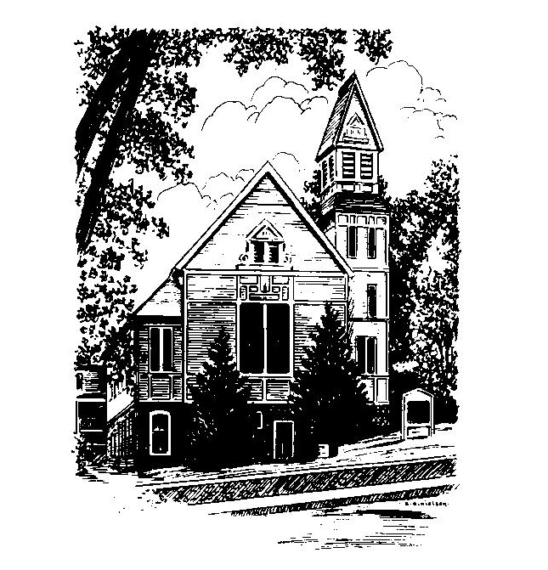
To Contact Us:
Church Office: 978-939-8821
Church website: www.baldwinvillecongochurch.org
Organist: Michelle Salvanelli
Videographer: Jeff Salvanelli
Church Wi-Fi password: Memorial 1874

Deacon of the Month: Joanne Francis
Liturgist: Nowell Francis
Our current supply preacher is Rev. Mike Scott.
Today: Coffee and conversation downstairs
Discernment Committee will meet following worship, and
again at 2:00 with representatives from New Hope Chapel.

*denotes “All who are able please stand”. Masking is optional

Meditation Thought

Who knows how the awareness of God's love first hits people. We all have our own tales to tell, including those of us who wouldn't believe in God if you paid us. Some moment happens in your life that you say yes to right up to the roots of your hair, that makes it worth having been born just to have happen. Laughing with somebody till the tears run down your cheeks. Waking up to the first snow. Being in bed with somebody you love.
Whether you thank God for such a moment or thank your lucky stars, it is a moment that is trying to open up your whole life. If you turn your back on such a moment and hurry along to business as usual, it may lose you the ball game. If you throw your arms around such a moment and bless it, it may save your soul.
How about the person you know who as far as you can possibly tell has never had such a moment—one of those soreheads and slobs of the world, the ones the world has hopelessly crippled? Maybe for that person the moment that has to happen is you.

-Frederick Buechner
(Originally from Wishful Thinking and reprinted in Beyond Words)

MEMORIAL CONGREGATIONAL CHURCH U.C.C. BALDWINVILLE, MA.
An Open and Affirming Church of
the United Church of Christ

March 17, 2024

No Matter Who You Are, No Matter Where
You Are on Life’s Journey; You Are Welcome Here!

The Fifth Sunday in Lent

PRELUDE

WELCOME

CALL TO WORSHIP

Leader: Out of the fullness of life we have come to sing
and celebrate..
People: Let us bring our joy and our hopefulness.
Leader: Out of our sorrow and incompleteness we have
come to pray and seek guidance.
People: Let us bring the integrity of our real selves.
Leader: Let us bring full hearts, open minds, and yearning
spirits.
People: Come, let us worship!

*HYMN Lift High the Cross Black Hymnal #198

*UNISON PRAYER OF INVOCATION Based on Psalm 131

O Holy Presence and Ground of All Being, our eyes are not raised too high this morning. We do not occupy ourselves with things too great and too marvelous for us. But we have come here to calm and quiet our hearts, that we might, like children who are drawn to their mother’s love, be brought closer to you and to the hope you offer to every soul and in every age. Amen.

*SHARING THE PEACE OF CHRIST
One: May the peace of Christ be with you!
Many: And also with you!
--Please “Pass the Peace” however you feel comfortable
as we sing Amen!
*AMEN (Sung twice) Red Hymnal #317
Amen, Amen, Amen, Amen, Amen

OFFERING OURSELVES AND OUR GIFTS

CALL TO GIVING

As our offering is brought forward let us sing:
Praise God, from whom all blessings flow;
Praise God, all creatures here below;
Alleluia! Alleluia!
Praise God above, you heavenly host;
Praise Father, Son, and Holy Ghost.
Alleluia! Alleluia! Alleluia!
Alleluia! Alleluia!

PRAYER OF DEDICATION
FIRST SCRIPTURE READING Jeremiah 31:31-34

SPECIAL MUSIC

GOSPEL READING John 12:20-33

MESSAGE What Is Faithfulness? Mike Scott

*HYMN Just As I Am Black Hymnal #207

SHARING OUR PRAYERS, OUR JOYS, OUR HOPES

PASTORAL PRAYER

THE LORD’S PRAYER

Our father who art in heaven hallowed be thy name. Thy kingdom come thy will be done on earth as it is in heaven. Give us this day our daily bread and forgive us our trespasses as we forgive those who trespass against us. And lead us not into temptation but deliver us from evil. For thine is the kingdom and the power and the glory forever. Amen.
-Response (singing)
Hear our Prayer, O Lord, Hear our prayer O Lord.
Incline thine ear to us, and grant us thy peace. Amen

*HYMN: I’ve Got Peace Like a River
Black Hymnal #478

*BENEDICTION

POSTLUDE

