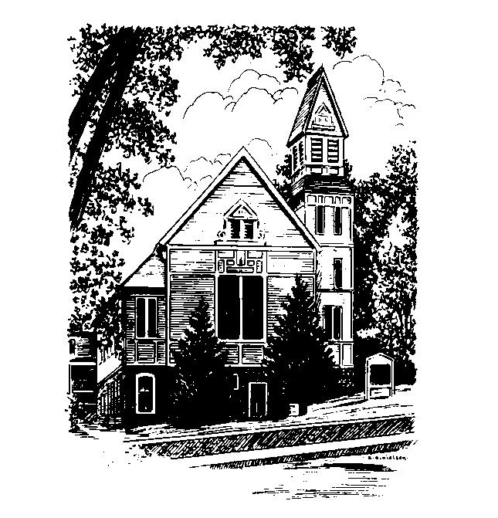
To Contact Us:
Church Office: 978-939-8821
Church website: www.baldwinvillecongochurch.org
Organist: Michelle Salvanelli
Videographer: Jeff Salvanelli
Church Wi-Fi password: Memorial 1874

Deacon of the Month: Joanne Francis
Liturgist: Nowell Francis
Our current supply preacher is Rev. Mike Scott.
Today: Coffee and conversation downstairs
COMMUNION TODAY
We take communion by intinction. We invite all who would share in Christ’s grace to come forward and take bread and dip it in the communion cup and eat with the blessing of Christ.
*denotes “All who are able please stand”. Masking is optional

Meditation Thought

"The folly of what we preach," Paul called it (1:21) . . .
Who stood by Jesus when the going got rough, after all? He even goes so far as to speak of "the foolishness of God" (1:25). What other way could you describe a deity who chose as his followers not the movers and shakers who could build him a temple to make Aphrodite's look like two cents but the weak, the despised, the ones who were foolish even as their God was and poor as church mice?

- Frederick Buechner

(From Secrets in the Dark)
MEMORIAL CONGREGATIONAL CHURCH U.C.C. BALDWINVILLE, MA.
An Open and Affirming Church of
the United Church of Christ
March 3, 2024
No Matter Who You Are, No Matter Where
You Are on Life’s Journey; You Are Welcome Here!

The Third Sunday in Lent

PRELUDE

WELCOME

CALL TO WORSHIP

Leader: May the Good News of Christ open our hearts
People: that we may listen and hear,
Leader: open our minds
People: that we may appreciate and understand how
blessed we are to share the bread and cup,
to join hands here, and touch holiness!

*HYMN Spirit Red Hymnal #249

UNISON PRAYER OF OPENNESS TO THE SPIRIT

Our hearts are open, O Spirit of Holiness – ready to sing and celebrate the wonder of your great creation. Our hearts are open – ready to dance in the spirit of praise for all good gifts. Our hearts are open – ready to laugh and love and live in thankfulness and joy. Fill our hearts to overflowing in this hour, we pray, that we might be a wellspring of thanksgiving to those around us. Amen.
*SHARING THE PEACE OF CHRIST
One: May the peace of Christ be with you!
Many: And also with you!
--Please “Pass the Peace” however you feel comfortable
as we sing Amen!
*AMEN (Sung twice) Red Hymnal #317
Amen, Amen, Amen, Amen, Amen

OFFERING OURSELVES AND OUR GIFTS
CALL TO GIVING
As our offering is brought forward let us sing:
Praise God, from whom all blessings flow;
Praise God, all creatures here below;
Alleluia! Alleluia!
Praise God above, you heavenly host;
Praise Father, Son, and Holy Ghost.
Alleluia! Alleluia! Alleluia!
Alleluia! Alleluia!
PRAYER OF DEDICATION

FIRST SCRIPTURE 1 Corinthians 1:18-31

SPECIAL MUSIC

GOSPEL READING John 2:13-22

MESSAGE Turning the world Upside Down
Mike Scott

*HYMN O Jesus, I have Promised Red Hymnal #612

SHARING OUR PRAYERS, OUR JOYS, OUR HOPES

PASTORAL PRAYER
THE LORD’S PRAYER
Our father who art in heaven hallowed be thy name. Thy kingdom come thy will be done on earth as it is in heaven. Give us this day our daily bread and forgive us our trespasses as we forgive those who trespass against us. And lead us not into temptation but deliver us from evil. For thine is the kingdom and the power and the glory forever. Amen.
-Response (sung)
Hear our Prayer, O Lord, Hear our prayer O Lord.
Incline thine ear to us, and grant us thy peace. Amen

INVITATION TO THE TABLE
Everyone, of any age, who seeks Christ’s presence
is welcome at this table!.

WORDS OF INSTITUTION

DECLARATION:
Minister: And so, remembering what Christ has done for us,
we come to this table in thanksgiving and commitment,
affirming the ancient creed of our faith:
ALL: (Singing) Christ has died. Christ has Risen.
Christ will come again.

SHARING THE BREAD AND CUP

*HYMN: Jesus Calls Us O’er the Tumult
Red Hymnal # 337

*BENEDICTION

POSTLUDE

