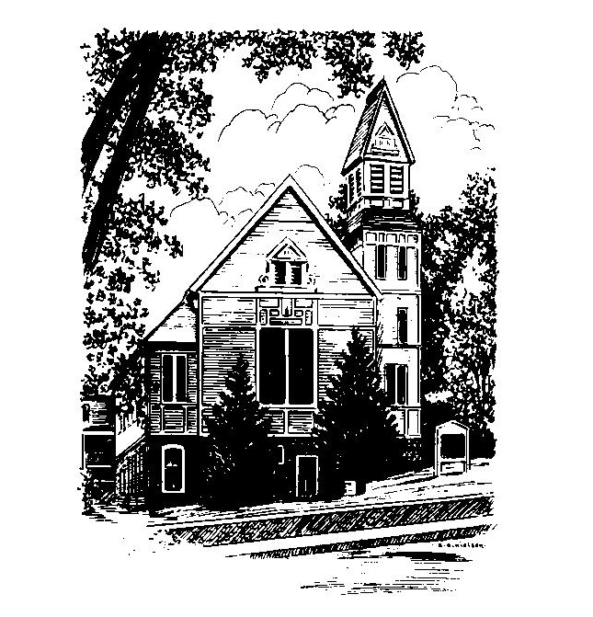
To Contact Us:
Church Office: 978-939-8821
Church website: www.baldwinvillecongochurch.org
Organist: Michelle Salvanelli
Videographer: Jeff Salvanelli
Church Wi-Fi password: Memorial 1874

Deacon of the Month: Nancy Heaney
Liturgist: Nancy Heaney
Our current supply preacher is Rev. Mike Scott.
Today: Coffee and conversation downstairs

*denotes “All who are able please stand”. Masking is optional

Meditation Thought

Sarah was never going to see ninety again, and Abraham had already hit one hundred, and when the angel told them that the stork was on its way at last, they both of them almost collapsed. Abraham laughed "till he fell on his face" (Genesis 17:17), and Sarah stood cackling behind the tent door so the angel wouldn't think she was being rude as the tears streamed down her cheeks. When the baby finally came, they even called him "Laughter"—which is what Isaac means in Hebrew—because obviously no other name would do. . . .
Sarah and her husband had had plenty of hard knocks in their time, and there were plenty more of them still to come, but at that moment when the angel told them they'd better start dipping into their old-age pensions for cash to build a nursery, the reason they laughed was that it suddenly dawned on them that the wildest dreams they'd ever had hadn't been half wild enough.
-Frederick Buechner
(-Originally published in Peculiar Treasures and later in Beyond Words)

MEMORIAL CONGREGATIONAL CHURCH U.C.C. BALDWINVILLE, MA.
An Open and Affirming Church of
the United Church of Christ

February 25, 2024

No Matter Who You Are, No Matter Where
You Are on Life’s Journey; You Are Welcome Here!

The Second Sunday in Lent

PRELUDE

WELCOME

CALL TO WORSHIP

Leader: Let us come together to sing and pray.
People: We pray and sing as with one voice.
Leader: Let us come together to share the peace
and hear the word.
People: We come as brothers and sisters in faith
and join our hearts in praise.
Leader: We are members of the Body of Christ,
and members of one another.
People: Let us celebrate the Christ who makes us one!

*HYMN On a Hill Far Away Black Hymnal #195

*OPENING PRAYER (unison)

Lord of All, through Jesus Christ and the truth he revealed you have set us free. Help us in this service of praise to sing of our freedom with joy, to long for it in our prayers, and to be assured of it in the proclamation of your word. Amen.

*SHARING THE PEACE OF CHRIST
One: May the peace of Christ be with you!
Many: And also with you!
--Please “Pass the Peace” however you feel comfortable
as we sing Amen!
*AMEN (Sung twice) Red Hymnal #317
Amen, Amen, Amen, Amen, Amen

OFFERING OURSELVES AND OUR GIFTS

CALL TO GIVING

As our offering is brought forward let us sing:
Praise God, from whom all blessings flow;
Praise God, all creatures here below;
Alleluia! Alleluia!
Praise God above, you heavenly host;
Praise Father, Son, and Holy Ghost.
Alleluia! Alleluia! Alleluia!
Alleluia! Alleluia!

PRAYER OF DEDICATION

FIRST SCRIPTURE READING Psalm 22:23-31

SPECIAL MUSIC

GOSPEL READING Mark 8:31-38

MESSAGE Why Is There Suffering? Mike Scott

*HYMN Be Still, My Soul Black Hymnal #488

SHARING OUR PRAYERS, OUR JOYS, OUR HOPES

PASTORAL PRAYER

THE LORD’S PRAYER

Our father who art in heaven hallowed be thy name. Thy kingdom come thy will be done on earth as it is in heaven. Give us this day our daily bread and forgive us our trespasses as we forgive those who trespass against us. And lead us not into temptation but deliver us from evil. For thine is the kingdom and the power and the glory forever. Amen.
-Response (singing)
Hear our Prayer, O Lord, Hear our prayer O Lord.
Incline thine ear to us, and grant us thy peace. Amen

*HYMN: Christ Is Made the Sure Foundation
Black Hymnal #400

*BENEDICTION

POSTLUDE

