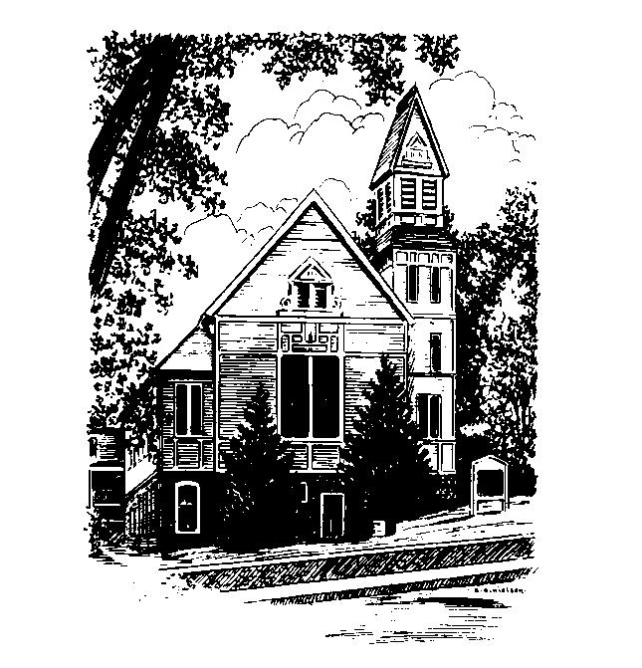
To Contact Us:
Church Office: 978-939-8821
Church website: www.baldwinvillecongochurch.org
Organist: Michelle Salvanelli
Videographer: Jeff Salvanelli
Church Wi-Fi password: Memorial 1874

Deacon of the Month: Nancy Heaney
Liturgist: Nancy Heaney
Our current supply preacher is Rev. Mike Scott.
Today: Coffee and conversation downstairs

*denotes “All who are able please stand”. Masking is optional

Meditation Thought

The waters had all drained off and the ground was dry again when God hung a rainbow in the sky to remind him he'd promised "that never again shall all flesh be cut off by the waters of a flood" (Genesis 9:11). . . .
In one way, then, it gave Noah a nice warm feeling . . ., but in another way it gave him an uneasy twinge. If God needed the rainbow as a reminder, he thought, that could mean that, if someday God didn't happen to look in the right direction or had something else on his mind, he might forget his promise and the heavy drops would start pattering down on the roof a second time. . . .
But . . . the great promise echoed in his ears. "Never again;" God had said, and Noah clung on to those words like a raft in a high sea.

-Frederick Buechner
(-Originally published in Beyond Words)

MEMORIAL CONGREGATIONAL CHURCH U.C.C. BALDWINVILLE, MA.
An Open and Affirming Church of
the United Church of Christ
February 18, 2024

No Matter Who You Are, No Matter Where
You Are on Life’s Journey; You Are Welcome Here!

The First Sunday in Lent

PRELUDE

WELCOME

CALL TO WORSHIP

Leader: We come to worship the Lord of Life who
inhabits our world and our very lives.
People: We need not look up to find the Creator at
work. We look around and within.
Leader: We need not listen for a voice like thunder,
but simply open our ears to the music of life.
People: In this hour of worship let us seek and find the
Spirit of Holiness dwelling in our midst; let
us rediscover the divine mystery in the
heart of life. Come, let us worship.

*HYMN God, Whose Giving Knows no Ending
Red Hymnal #606

*OPENING PRAYER (unison)

This morning, O Spirit of Holiness, we glory in your sea of creativity and ocean of compassion, whose flow and cresting waves of magnificence draw us to praise and prayer. We glimpse you in creation’s untiring quest, in humanity’s imaginative potential, in the stirring and discoveries of our own hearts. You invite us to joyous oneness and life abundant, and we cannot help but respond with praise and thanksgiving. We come before you abounding in hope, and rededicating ourselves to ministries of grace. Amen.
*SHARING THE PEACE OF CHRIST
One: May the peace of Christ be with you!
Many: And also with you!
--Please “Pass the Peace” however you feel comfortable
as we sing Amen!
*AMEN (Sung twice) Red Hymnal #317
Amen, Amen, Amen, Amen, Amen

OFFERING OURSELVES AND OUR GIFTS

CALL TO GIVING

As our offering is brought forward let us sing:
Praise God, from whom all blessings flow;
Praise God, all creatures here below;
Alleluia! Alleluia!
Praise God above, you heavenly host;
Praise Father, Son, and Holy Ghost.
Alleluia! Alleluia! Alleluia!
Alleluia! Alleluia!

PRAYER OF DEDICATION
FIRST SCRIPTURE READING Genesis 9:8-17

SPECIAL MUSIC

GOSPEL READING Mark 1:9-15

MESSAGE Of Water and Beasts:
Reflections on a Timeless Covenant
Mike Scott

*HYMN We Cannot Own the Sunlit Sky
Red Hymnal #684

SHARING OUR PRAYERS, OUR JOYS, OUR HOPES

PASTORAL PRAYER

THE LORD’S PRAYER

Our father who art in heaven hallowed be thy name. Thy kingdom come thy will be done on earth as it is in heaven. Give us this day our daily bread and forgive us our trespasses as we forgive those who trespass against us. And lead us not into temptation but deliver us from evil. For thine is the kingdom and the power and the glory forever. Amen.
-Response (singing)
Hear our Prayer, O Lord, Hear our prayer O Lord.
Incline thine ear to us, and grant us thy peace. Amen

*HYMN: Lead On, O Cloud of Presence Red Hymnal #633

*BENEDICTION

POSTLUDE

