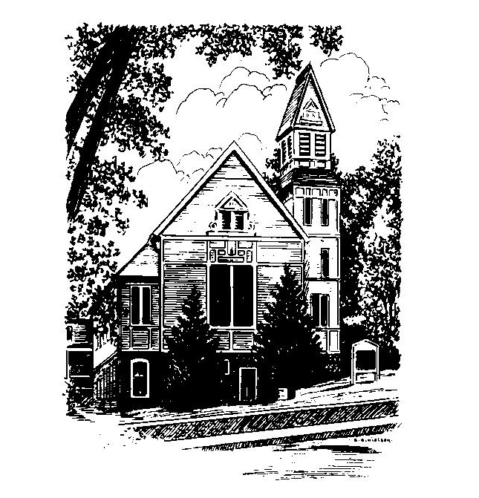
To Contact Us:
Church Office: 978-939-8821
Church website: www.baldwinvillecongochurch.org
Organist: Michelle Salvanelli
Videographer: Jeff Salvanelli
Church Wi-Fi password: Memorial 1874

Deacon of the Month: Nancy Heaney
Liturgist: Nancy Heaney
Our current supply preacher is Rev. Mike Scott.
Today: Coffee and conversation downstairs
The Deacons will meet after worship.
(Today’s Discernment Committee meeting
has been rescheduled to February 18.)

*denotes “All who are able please stand”. Masking is optional

Meditation Thought

Frederick Buechner on “the transfiguration”

It is as strange a scene as there is in the Gospels. Even without the voice from the cloud to explain it, they had no doubt what they were witnessing. . . . It was the holiness of the man shining through his humanness, his face so afire with it they were almost blinded.
Even with us something like that happens once in a while. The face of a man walking with his child in the park, of a woman baking bread, of sometimes even the unlikeliest person listening to a concert, say, or standing barefoot in the sand watching the waves roll in, or just having a beer at a Saturday baseball game in July. Every once and so often, something so touching, so incandescent, so alive transfigures the human face that it's almost beyond bearing.
(-Originally published in Whistling in the Dark)

MEMORIAL CONGREGATIONAL CHURCH U.C.C. BALDWINVILLE, MA.
An Open and Affirming Church of
the United Church of Christ
February 11, 2024

No Matter Who You Are, No Matter Where
You Are on Life’s Journey; You Are Welcome Here!

PRELUDE

WELCOME

CALL TO WORSHIP

Leader: We come seeking Holy Love,
that we may become whole and loving.
People: We come seeking the Spirit
that fills the world with hope,
that we might be filled with that same
Spirit and hope.
Leader: In humbleness, faith, and thanksgiving,
let us rejoice in the Spirit’s presence.
People: Come, let us worship.

*HYMN We Have Come at Christ’s Own Bidding
Black Hymnal #182

*OPENING PRAYER (unison)

Divine and Eternal Mother and Father of All, we are your children and you love us. So deep is your love that nothing we have done, or thought to do, shall take away the peace you give. So strong is your love that no passing trouble shall tear us from your arms. So precious is your love that all our life shall be lived in your service, and in praise to you. Amen.
*SHARING THE PEACE OF CHRIST
One: May the peace of Christ be with you!
Many: And also with you!
--Please “Pass the Peace” however you feel comfortable
as we sing Amen!
*AMEN (Sung twice) Red Hymnal #317
Amen, Amen, Amen, Amen, Amen

OFFERING OURSELVES AND OUR GIFTS

CALL TO GIVING

As our offering is brought forward let us sing:
Praise God, from whom all blessings flow;
Praise God, all creatures here below;
Alleluia! Alleluia!
Praise God above, you heavenly host;
Praise Father, Son, and Holy Ghost.
Alleluia! Alleluia! Alleluia!
Alleluia! Alleluia!

PRAYER OF DEDICATION

FIRST SCRIPTURE READING Psalm 50:1-6

SPECIAL MUSIC

GOSPEL READING Mark 9:2-9

MESSAGE A Mountaintop Experience Mike Scott

*HYMN Stars and Planets Flung in Orbit
Black Hymnal #567

SHARING OUR PRAYERS, OUR JOYS, OUR HOPES

PASTORAL PRAYER

THE LORD’S PRAYER

Our father who art in heaven hallowed be thy name. Thy kingdom come thy will be done on earth as it is in heaven. Give us this day our daily bread and forgive us our trespasses as we forgive those who trespass against us. And lead us not into temptation but deliver us from evil. For thine is the kingdom and the power and the glory forever. Amen.
-Response (singing)
Hear our Prayer, O Lord, Hear our prayer O Lord.
Incline thine ear to us, and grant us thy peace. Amen

*HYMN: Between the Lines (Insert)

*BENEDICTION

POSTLUDE

