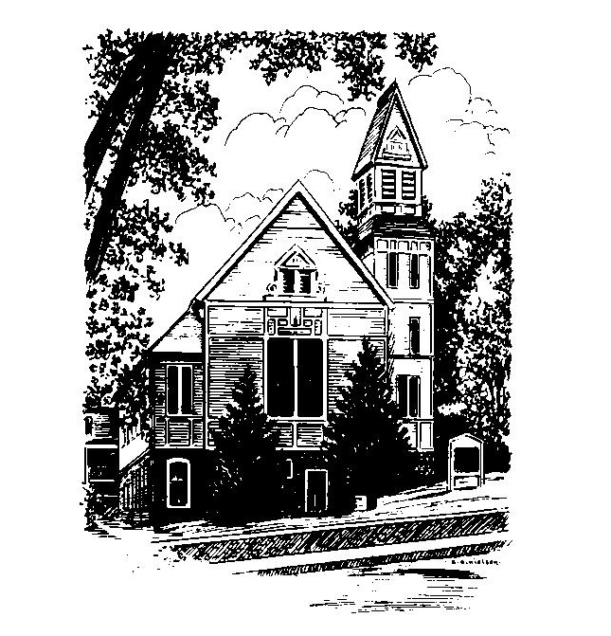
To Contact Us:
Church Office: 978-939-8821
Church website: www.baldwinvillecongochurch.org
Organist: Michelle Salvanelli
Videographer: Jeff Salvanelli
Church Wi-Fi password: Memorial 1874

Deacon of the Month: Nancy Heaney
Liturgist: Nancy Heaney
Our current supply preacher is Rev. Mike Scott.
Today: Coffee and conversation downstairs
COMMUNION TODAY
We take communion by intinction. We invite all who would share in Christ’s grace to come forward and take bread and dip it in the communion cup and eat with the blessing of Christ.
*denotes “All who are able please stand”. Masking is optional

Meditation Thought

Compassion is the sometimes fatal capacity for feeling what it's like to live inside somebody else's skin.
It is the knowledge that there can never really be any peace and joy for me until there is peace and joy finally for you too.
- Frederick Buechner

(originally published in Wishful Thinking and later in Beyond Words)

MEMORIAL CONGREGATIONAL CHURCH U.C.C. BALDWINVILLE, MA.
An Open and Affirming Church of
the United Church of Christ
February 4, 2024
No Matter Who You Are, No Matter Where
You Are on Life’s Journey; You Are Welcome Here!

PRELUDE

WELCOME

CALL TO WORSHIP

Leader: Sisters and brothers, we have come together to
celebrate the love and grace of Christ that bind
us together as children of hope.
People: We are here to share our laughter and tears,
our confidence and fear, our hurt and our joy.
Leader: Come as you are; come ready to be filled,
to be changed, to be redeemed.
People: Come, let us worship.

*HYMN Praise to the Lord, the Almighty Red Hymnal #25

PRAYER OF APPROACH (Unison)
Lord of Hosts, you are the source of our life.
Gather us now, we pray. Form us into a holy
community of your own people. Mold us by the
breath of your holy spirit. Reveal in this corporate
body the face of your anointed Christ. Amen.

*SHARING THE PEACE OF CHRIST
One: May the peace of Christ be with you!
Many: And also with you!
--Please “Pass the Peace” however you feel comfortable
as we sing Amen!
*AMEN (Sung twice) Red Hymnal #317
Amen, Amen, Amen, Amen, Amen

OFFERING OURSELVES AND OUR GIFTS
CALL TO GIVING
As our offering is brought forward let us sing:
Praise God, from whom all blessings flow;
Praise God, all creatures here below;
Alleluia! Alleluia!
Praise God above, you heavenly host;
Praise Father, Son, and Holy Ghost.
Alleluia! Alleluia! Alleluia!
Alleluia! Alleluia!
PRAYER OF DEDICATION

FIRST SCRIPTURE 1 Corinthians 9:16-23

SPECIAL MUSIC

GOSPEL READING Mark 1:29-39

MESSAGE All Things to All People Mike Scott

*HYMN Lord, I Want to Be a Christian Red Hymnal #589

SHARING OUR PRAYERS, OUR JOYS, OUR HOPES

PASTORAL PRAYER
THE LORD’S PRAYER
Our father who art in heaven hallowed be thy name. Thy kingdom come thy will be done on earth as it is in heaven. Give us this day our daily bread and forgive us our trespasses as we forgive those who trespass against us. And lead us not into temptation but deliver us from evil. For thine is the kingdom and the power and the glory forever. Amen.
-Response (sung)
Hear our Prayer, O Lord, Hear our prayer O Lord.
Incline thine ear to us, and grant us thy peace. Amen

INVITATION TO THE TABLE
Everyone, of any age, who seeks Christ’s presence
is welcome at this table!.

WORDS OF INSTITUTION

DECLARATION:
Minister: And so, remembering what Christ has done for us,
we come to this table in thanksgiving and commitment,
affirming the ancient creed of our faith:
ALL: (Sung) Christ has died. Christ has Risen.
Christ will come again.

SHARING THE BREAD AND CUP

*HYMN: Be Thou My Vision Red Hymnal # 595

*BENEDICTION

POSTLUDE

