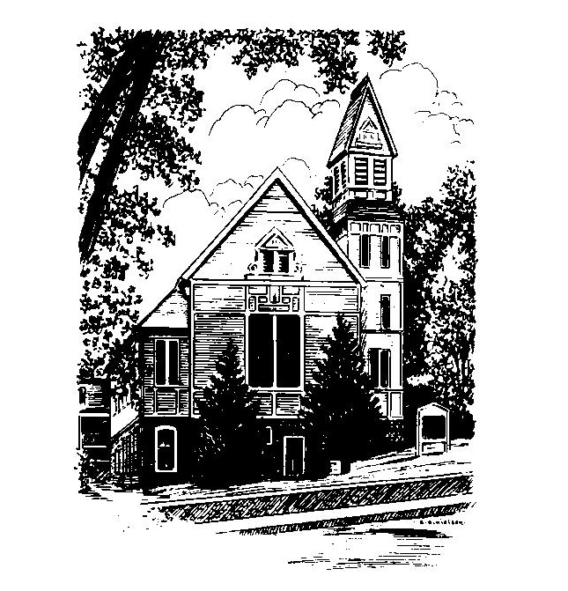
To Contact Us:
Church Office: 978-939-8821
Church website: www.baldwinvillecongochurch.org
Organist: Michelle Salvanelli
Videographer: Jeff Salvanelli
Church Wi-Fi password: Memorial 1874

Deacon of the Day: Lei Messer
Liturgist: Lei Messer
Our current supply preacher is Rev. Mike Scott.
Today: Coffee and conversation downstairs

There will be a brief meeting of the Discernment
Committee following worship.

*denotes “All who are able please stand”. Masking is optional

Meditation Thought

“…for Jesus the only distinction between men that ultimately matters seems to be not whether they are churchgoers or non-churchgoers, communists or capitalists, Catholics or Protestants or Jews, but do they or do they not love - love not in the sense of an emotion so much as in the sense of an act of the will, the loving act of willing another's good even, if need arise, at the expense of their own. "Hell is the suffering of being unable to love," said old Father Zossima or, as John puts it in his first epistle, "He who does not love remains in death."”
-Frederick Buechner
(-Originally published in The Faces of Jesus)

MEMORIAL CONGREGATIONAL CHURCH U.C.C. BALDWINVILLE, MA.
An Open and Affirming Church of
the United Church of Christ
January 21, 2024

No Matter Who You Are, No Matter Where
You Are on Life’s Journey; You Are Welcome Here!

PRELUDE

WELCOME

CALL TO WORSHIP

Leader: May the peace of the Lord rest upon our busy lives so that we may be quieted into prayer.
People: May the love of Christ flow through our worship words that we may be drawn into graceful fellowship and opportunities for service.
Leader: May the grace of the Spirit seek out our every need and may the restless gospel set our hearts afire.
People: Let us worship in spirit and in truth.

*HYMN O God of Vision Red Hymnal #288

*OPENING PRAYER (unison)

Spirit of Holiness, move among us and free us to love and serve you and to demonstrate your loving and gracious spirit in all our relationships. Refresh our hearts and minds, that we may not be weary in seeking your ways. Whisper to us in a still, small voice; reveal to us your will. Guide us to others with whom we may share the labors of peace and justice; through the grace of Jesus Christ we pray. Amen.
*SHARING THE PEACE OF CHRIST
One: May the peace of Christ be with you!
Many: And also with you!
--Please “Pass the Peace” however you feel comfortable
as we sing Amen!
*AMEN (Sung twice) Red Hymnal #317
Amen, Amen, Amen, Amen, Amen

OFFERING OURSELVES AND OUR GIFTS

CALL TO GIVING

As our offering is brought forward let us sing:
Praise God, from whom all blessings flow;
Praise God, all creatures here below;
Alleluia! Alleluia!
Praise God above, you heavenly host;
Praise Father, Son, and Holy Ghost.
Alleluia! Alleluia! Alleluia!
Alleluia! Alleluia!

PRAYER OF DEDICATION

FIRST SCRIPTURE READINGS Jonah 3:1-5, 10
1 Corinthians 7:29-31

SPECIAL MUSIC

GOSPEL READING Mark 1:14-20

MESSAGE Many Gates Mike Scott

*HYMN In Christ There Is No East Or West
Red Hymnal #687

SHARING OUR PRAYERS, OUR JOYS, OUR HOPES

PASTORAL PRAYER

THE LORD’S PRAYER

Our father who art in heaven hallowed be thy name. Thy kingdom come thy will be done on earth as it is in heaven. Give us this day our daily bread and forgive us our trespasses as we forgive those who trespass against us. And lead us not into temptation but deliver us from evil. For thine is the kingdom and the power and the glory forever. Amen.
-Response (singing)
Hear our Prayer, O Lord, Hear our prayer O Lord.
Incline thine ear to us, and grant us thy peace. Amen

*HYMN: Restless Weaver Red Hymnal # 658

*BENEDICTION

POSTLUDE

