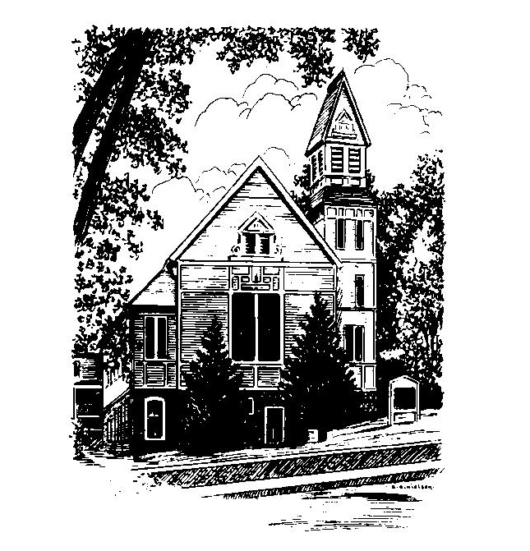
To Contact Us:
Church Office: 978-939-8821
Church website: www.baldwinvillecongochurch.org
Organist: Michelle Salvanelli
Videographer: Jeff Salvanelli
Church Wi-Fi password: Memorial 1874

Deacon of the Month: Lei Messer
Liturgist: Lei Messer
Our current supply preacher is Rev. Mike Scott.
Today: Coffee and conversation downstairs
Deacons will meet after worship
Trustees will meet after worship

COMMUNION TODAY
We take communion by intinction. We invite all who would share in Christ’s grace to come forward and take bread and dip it in the communion cup and eat with the blessing of Christ.
*denotes “All who are able please stand”. Masking is optional

Meditation Thought

“Adeste fidelis [Come all ye faithful]. Come and behold him, born the king of angels. Speak to him or be silent before him. In whatever way seems right to you and at whatever time, come to him with your empty hands. The great promise is that to come to him who was born at Bethlehem is to find coming to birth within ourselves something stronger and braver, gladder and kinder and holier, than ever we knew before or than ever we could have known without him..”
-Frederich Buechner

(From the book Secrets in the Dark.)

MEMORIAL CONGREGATIONAL CHURCH U.C.C. BALDWINVILLE, MA.
An Open and Affirming Church of
the United Church of Christ
January 14, 2024
No Matter Who You Are, No Matter Where
You Are on Life’s Journey; You Are Welcome Here!

PRELUDE

WELCOME

CALL TO WORSHIP

Leader: Come; let us celebrate the bread of life, broken for us.
People: Let us make a feast of bread and wine, and spirit, and song.
Leader: Let many guests join us: our friends and neighbors, and the hungry and battle worn of other lands.
People: Let us, together, knead the bread of spirit and pour the wine of love.
Leader: Let us set before one another a holy meal of love and good works.
People: Let no one go away hungry.

*HYMN O God, Our Help in Ages Past Red Hymnal #67

*UNISON PRAYER OF OPENNESS TO THE SPIRIT
Your steadfast love to us is our joy, O Lord of Hosts. We gather to rejoice in your grace and mercy which greet us each day with the rising sun. We gather to sing praises to you for all good gifts. You have called us to faith and service and have given us strength to respond to your calling. You have joined us together in love. Hear our prayers and our praise in Christ's name. Amen.

*SHARING THE PEACE OF CHRIST
One: May the peace of Christ be with you!
Many: And also with you!
--Please “Pass the Peace” however you feel comfortable
as we sing Amen!
*AMEN (Sung twice) Red Hymnal #317
Amen, Amen, Amen, Amen, Amen

OFFERING OURSELVES AND OUR GIFTS
CALL TO GIVING
As our offering is brought forward let us sing:
Praise God, from whom all blessings flow;
Praise God, all creatures here below;
Alleluia! Alleluia!
Praise God above, you heavenly host;
Praise Father, Son, and Holy Ghost.
Alleluia! Alleluia! Alleluia!
Alleluia! Alleluia!
PRAYER OF DEDICATION

FIRST SCRIPTURE Psalm 139:1-6, 13-18
SPECIAL MUSIC
SECOND SCRIPTURE John 1:43-51
MESSAGE Come and See Mike Scott

*COMMUNION HYMN
Let Us Talents and Tongues Employ Red Hymnal #422

SHARING OUR PRAYERS, OUR JOYS, OUR HOPES

PASTORAL PRAYER

THE LORD’S PRAYER
Our father who art in heaven hallowed be thy name. Thy kingdom come thy will be done on earth as it is in heaven. Give us this day our daily bread and forgive us our trespasses as we forgive those who trespass against us. And lead us not into temptation but deliver us from evil. For thine is the kingdom and the power and the glory forever. Amen.
-Response (sung)
Hear our Prayer, O Lord, Hear our prayer O Lord.
Incline thine ear to us, and grant us thy peace. Amen

INVITATION TO THE TABLE
Everyone, of any age, who seeks Christ’s presence
is welcome at this table!.

WORDS OF INSTITUTION

DECLARATION:
Minister: And so, remembering what Christ has done for us,
we come to this table in thanksgiving and commitment,
affirming the ancient creed of our faith:
ALL: (Sung) Christ has died. Christ has Risen.
Christ will come again.

SHARING THE BREAD AND CUP

*HYMN: Where Cross the Crowded Ways of Life
Red Hymnal #665

*BENEDICTION

POSTLUDE

