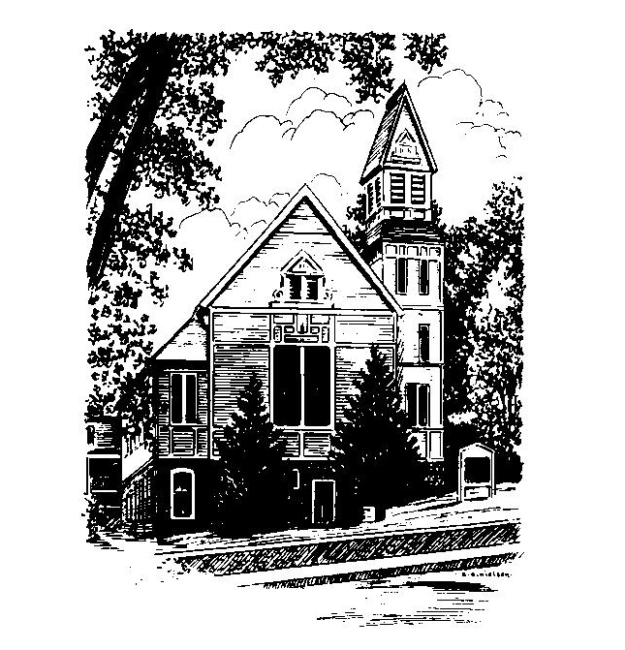
To Contact Us:
Church Office: 978-939-8821
Church website: www.baldwinvillecongochurch.org
Organist: Michelle Salvanelli
Videographer: Jeff Salvanelli
Church Wi-Fi password: Memorial 1874

Deacon of the Day: Barbara Woodbury
Liturgist: Barbara Woodbury
Our current supply preacher is Rev. Mike Scott.
Today: Coffee and conversation downstairs

*denotes “All who are able please stand”. Masking is optional

Meditation Thought

“. If anybody had predicted when I was an undergraduate at Princeton that I was going to be ordained as a minister ten years after graduation, I think I would have been flabbergasted. Yet as I wrote those two autobiographical volumes I found myself remembering small events as far back as early childhood which were even then leading me in something like that direction but so subtly and almost imperceptibly that it wasn't until decades had passed that I saw them for what they were—or thought I did because you can never be sure whether you are discovering that kind of truth or inventing it. The events were often so small that I was surprised to remember them, yet they turned out to have been road markers on a journey I didn't even know I was taking. The people involved in them were often people I had never thought of as having played particularly significant roles in my life yet looking back at them I saw that, for me, they had been life-givers, saints.”
-Frederick Buechner
(Originally published in Telling Secrets.)

MEMORIAL CONGREGATIONAL CHURCH U.C.C. BALDWINVILLE, MA.
An Open and Affirming Church of
the United Church of Christ
December 24, 2023

No Matter Who You Are, No Matter Where
You Are on Life’s Journey; You Are Welcome Here!

The Church Family Gathers
for the Fourth Sunday of Advent

PRELUDE

WELCOME

CALL TO WORSHIP
Leader: Such a large star for such a tiny babe,
People: Such a fuss over a poor child in a manger,
Leader: Such a loud song for such a quiet gift,
People: Such celebration for a little stranger,
Leader: Such a love to enter our lives so softly,
People: Such a life to fill our hearts with love! Let us sing our praises for this wondrous gift!

*HYMN Go, Tell It on the Mountain Red Hymnal #167

*OPENING PRAYER (unison)

Eternal Source of hope and author of human destiny, we seek you in this hour. Come to us, we pray, and fill our time of worship with an awareness of you. Fill our lives, our homes, and our world with the joy of giving, the devotion to service, and the peace that passes all understanding. Amen.

LIGHTING THE FOURTH CANDLE
ON THE ADVENT WREATH
Linda and Jim Bevan
CONGREGATIONAL RESPONSE
One Candle Is Lit (Verse 4 only) Red Hymnal #128

*SHARING THE PEACE OF CHRIST
One: May the peace of Christ be with you!
Many: And also with you!
--Please “Pass the Peace” however you feel comfortable
as we sing Amen!
*AMEN (Sung twice) Red Hymnal #317
Amen, Amen, Amen, Amen, Amen

OFFERING OURSELVES AND OUR GIFTS
CALL TO GIVING
As our offering is brought forward let us sing:
Praise God, from whom all blessings flow;
Praise God, all creatures here below;
Alleluia! Alleluia!
Praise God above, you heavenly host;
Praise Father, Son, and Holy Ghost.
Alleluia! Alleluia! Alleluia!
Alleluia! Alleluia!
PRAYER OF DEDICATION

FIRST SCRIPTURE Romans 16:25-27

SPECIAL MUSIC
SECOND SCRIPTURE Luke 2:15-19
MESSAGE The Carols of Christmas: Mike Scott
Silent Night

*HYMN Silent Night, Holy Night Red Hymnal #145

SHARING OUR PRAYERS, OUR JOYS, OUR HOPES

PASTORAL PRAYER
THE LORD’S PRAYER
Our father who art in heaven hallowed be thy name. Thy kingdom come thy will be done on earth as it is in heaven. Give us this day our daily bread and forgive us our trespasses as we forgive those who trespass against us. And lead us not into temptation but deliver us from evil. For thine is the kingdom and the power and the glory forever. Amen.
-Response (sung)
Hear our Prayer, O Lord, Hear our prayer O Lord.
Incline thine ear to us, and grant us thy peace. Amen

*HYMN: What Child Is This, Who Laid to Rest
Red Hymnal # 162

*BENEDICTION

POSTLUDE

