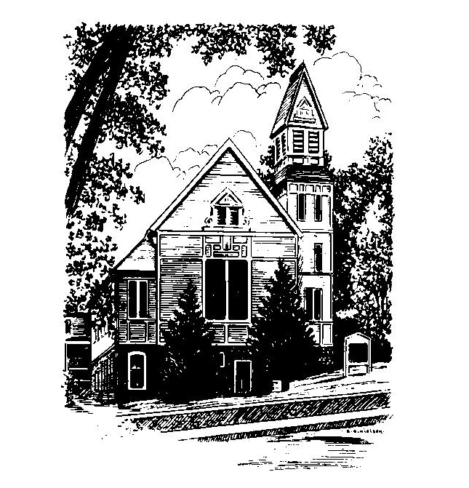
To Contact Us:
Church Office: 978-939-8821
Church website: www.baldwinvillecongochurch.org
Organist: Michelle Salvanelli
Videographer: Jeff Salvanelli
Church Wi-Fi password: Memorial 1874

Deacon of the Month: Nancy Heaney
Liturgist: Nancy Heaney
Our current supply preacher is Rev. Mike Scott.
Today:
We will decorate the sanctuary together after worship and then join in coffee and conversation downstairs.
*denotes “All who are able please stand”. Masking is optional

Meditation Thought

“…the news of the Gospel is that extraordinary things happen to [people] just as in fairy tales extraordinary things happen. Henry Ward Beecher cheats on his wife, his God, himself, but manages to keep on bringing the Gospel to life for people anyway, maybe even for himself. Lear goes berserk on a heath but comes out of it for a few brief hours every inch a king. Zaccheus climbs up a sycamore tree a crook and climbs down a saint. Paul sets out a hatchet man for the Pharisees and comes back a fool for Christ. It is impossible for anybody to leave behind the darkness of the world he carries on his back like a snail, but for God all things are possible. That is the fairy tale. All together they are the truth.”
-Frederick Buechner
(Originally published in Telling the Truth)

MEMORIAL CONGREGATIONAL CHURCH U.C.C. BALDWINVILLE, MA.
An Open and Affirming Church of
the United Church of Christ
November 26, 2023
No Matter Who You Are, No Matter Where
You Are on Life’s Journey; You Are Welcome Here!

Twenty-sixth Sunday after Pentecost

PRELUDE

WELCOME

CALL TO WORSHIP

Leader: In the message of Christ we find our identity.
People: In the spirit of Christ we find our unity.
Leader: In the love Christ we find our humanity.
People: Let us join together in singing praise and
thankfulness for the message, spirit,
and love of Christ. Come, let us worship.

*OPENING HYMN: Come, Ye Thankful People, Come
Red hymnal #718

UNISON PRAYER OF OPENNESS

We come with thanksgiving still on our lips, O Lord of Hosts. We thank you for triumphs of grace, for signs of renewal, for joys discovered in this fellowship of the Spirit. May we, in this time of worship, be strengthened to live by faith, walk in hope, and be empowered to give of ourselves in love. In the name of Christ, we pray. Amen.
*SHARING THE PEACE OF CHRIST
One: May the peace of Christ be with you!
Many: And also with you!
--Please “Pass the Peace” however you feel comfortable
as we sing Amen!
*AMEN (Sung twice) Red Hymnal #317
Amen, Amen, Amen, Amen, Amen

STEWARDSHIP MOMENT Nowell Francis

OFFERING OURSELVES AND OUR GIFTS
Call to Giving
*Offering and Doxology
(If you have not put you offering in the offering plate you may do so now)
--Our offering will be brought forward as we sing:
Praise God, from whom all blessings flow;
Praise God, all creatures here below;
Alleluia! Alleluia!
Praise God above, you heavenly host;
Creator, Christ, and Holy Ghost.
Alleluia! Alleluia! Alleluia!
Alleluia! Alleluia!
*Prayer of Dedication

FIRST SCRIPTURE Ephesians 1:15-23
SPECIAL MUSIC
SECOND SCRIPTURE Matthew 25:14-30
MESSAGE The Parable of the Talents Revisited:
Claiming Your Gifts Mike Scott

HYMN We Give Thee but Thine Own
Red Hymnal #382

SHARING OUR PRAYERS, OUR JOYS, OUR HOPES

PASTORAL PRAYER

THE LORD’S PRAYER
Our father who art in heaven hallowed be thy name. Thy kingdom come thy will be done on earth as it is in heaven. Give us this day our daily bread and forgive us our trespasses as we forgive those who trespass against us. And lead us not into temptation but deliver us from evil. For thine is the kingdom and the power and the glory forever. Amen.
-Response (sung)
Hear our Prayer, O Lord, Hear our prayer O Lord.
Incline thine ear to us, and grant us thy peace. Amen

*HYMN: For the Fruit of All Creation
Red Hymnal # 714

*BENEDICTION

POSTLUDE

