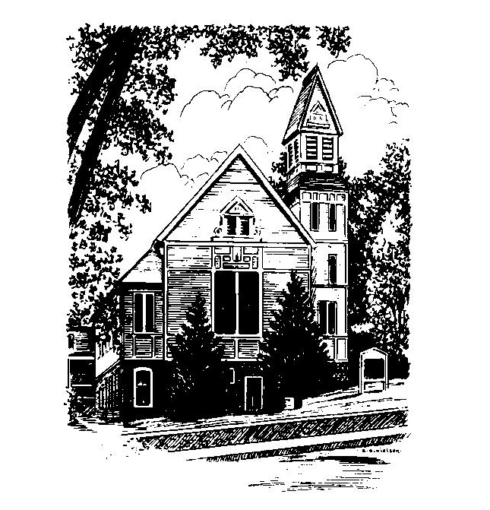
To Contact Us:
Church Office: 978-939-8821
Church website: www.baldwinvillecongochurch.org
Organist: Michelle Salvanelli
Videographer: Jeff Salvanelli
Church Wi-Fi password: Memorial 1874

Deacon of the Month: Nancy Heaney
Liturgist: Jim Bevan
Our current supply preacher is Rev. Mike Scott.

Today: Coffee and conversation downstairs
The Discernment Committee is meeting after worship
*denotes “All who are able please stand”. Masking is optional

Meditation Thought

“. . . joy is always all-encompassing; there is nothing of us left over to hate with or to be afraid with, to feel guilty with or to be selfish about. Joy is where the whole being is pointed in one direction, and it is something that by its nature a man never hoards but always wants to share . . . joy is a mystery because it can happen anywhere, anytime, even under the most unpromising circumstances, even in the midst of suffering, with tears in its eyes. Even nailed to a tree.”

-Frederick Buechner

(Originally published in The Hungering

MEMORIAL CONGREGATIONAL CHURCH U.C.C. BALDWINVILLE, MA.
An Open and Affirming Church of
the United Church of Christ
November 19, 2023
No Matter Who You Are, No Matter Where
You Are on Life’s Journey; You Are Welcome Here!

Twenty-fifth Sunday after Pentecost

PRELUDE

WELCOME

CALL TO WORSHIP

Leader: Rejoice, everyone! Celebrate the life within you.
People: In this time of worship we open our eyes to find
new meaning and purpose in the present,
and new hope in the future.
Leader: Rejoice, everyone! Give praise to the One
who is our wisdom and our strength.
People: We come now before the Ground of Our Being,
that we may be touched and empowered by the
Spirit.

*OPENING HYMN: Morning Has Broken
Red hymnal #53

UNISON PRAYER OF OPENNESS

O Lord of Life, distant yet near, we gather here in the assurance that if we seek you with all our hearts, we will surely find you. Be with us this day. Hear the confessions of our hearts, the yearnings of our minds, the pleadings our souls. Grant us your Spirit, that we may worship you in spirit and in truth. Amen.

*SHARING THE PEACE OF CHRIST
One: May the peace of Christ be with you!
Many: And also with you!
--Please “Pass the Peace” however you feel comfortable
as we sing Amen!
*AMEN (Sung twice) Red Hymnal #317
Amen, Amen, Amen, Amen, Amen

OFFERING OURSELVES AND OUR GIFTS TO GOD
Call to Giving
*Offering and Doxology
(If you have not put you offering in the offering plate you may do so now)
--Our offering will be brought forward as we sing:
Praise God, from whom all blessings flow;
Praise God, all creatures here below;
Alleluia! Alleluia!
Praise God above, you heavenly host;
Creator, Christ, and Holy Ghost.
Alleluia! Alleluia! Alleluia!
Alleluia! Alleluia!
*Prayer of Dedication

FIRST SCRIPTURE Psalm 90:1-12
SPECIAL MUSIC
SECOND SCRIPTURE Matthew 25:14-30
MESSAGE A Heart of Wisdom Mike Scott

HYMN O God, Our Help in Ages Past
Red Hymnal #67

SHARING OUR PRAYERS, OUR JOYS, OUR HOPES

PASTORAL PRAYER

THE LORD’S PRAYER
Our father who art in heaven hallowed be thy name. Thy kingdom come thy will be done on earth as it is in heaven. Give us this day our daily bread and forgive us our trespasses as we forgive those who trespass against us. And lead us not into temptation but deliver us from evil. For thine is the kingdom and the power and the glory forever. Amen.
-Response (sung)
Hear our Prayer, O Lord, Hear our prayer O Lord.
Incline thine ear to us, and grant us thy peace. Amen

*HYMN: Be Thou My Vision Red Hymnal # 595

*BENEDICTION

POSTLUDE

