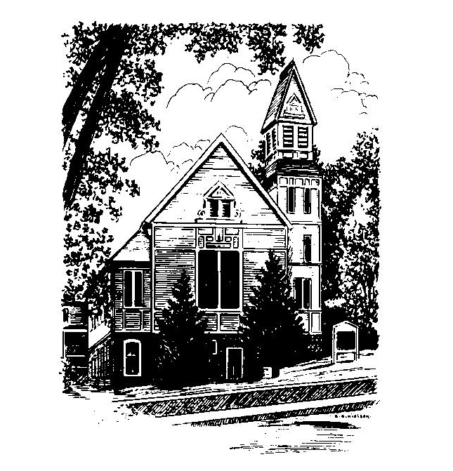
To Contact Us:
Church Office: 978-939-8821
Church website: www.baldwinvillecongochurch.org
Organist: Michelle Salvanelli
Videographer: Jeff Salvanelli
Church Wi-Fi password: Memorial 1874

Deacon of the Month: Nancy Heaney
Liturgist: Nowell Francis
Our current supply preacher is Rev. Mike Scott.

Today: Coffee and conversation downstairs
The Deacons are meeting after worship
*denotes “All who are able please stand”. Masking is optional

Meditation Thought

[In ancient Israel] . . . when God's demands seemed too exorbitant, God's promises too remote, she took up with all the other gods who still get our votes and our money and our 9 A.M. to 5 P.M. energies, because they are gods who could not care less whether we are holy or not, and promise absolutely everything we really want
and absolutely nothing we really need.

-Frederick Buechner

-Originally published in The Clown in the Belfry.

MEMORIAL CONGREGATIONAL CHURCH U.C.C. BALDWINVILLE, MA.
An Open and Affirming Church of
the United Church of Christ
November 12, 2023
No Matter Who You Are, No Matter Where
You Are on Life’s Journey; You Are Welcome Here!

Twenty-fourth Sunday after Pentecost
Veterans Day

PRELUDE

WELCOME

CALL TO WORSHIP

Leader: Let us praise the Lord of Life who makes all things
new.
People: Let us sing to the One who speaks still today,
making the Word of Truth alive to every
generation.
Leader: Let us turn to the One who sighs to us in the night
and speaks in the voice of friend.
People: We open our hearts and minds to the Spirit
and raise our voices in praise!

*OPENING HYMN: God of the Ages
Red hymnal #725

UNISON PRAYER OF OPENNESS
O Fount of Every Blessing, your steadfast love to us is our joy. We gather to rejoice in your salvation, to sing praises to you for all your healing gifts to us. You have called us to faith and have given us strength to live out that faith. You have joined us together in the life of Christ. Hear our prayers and our praise in Christ’s name. Amen.
*SHARING THE PEACE OF CHRIST
One: May the peace of Christ be with you!
Many: And also with you!
--Please “Pass the Peace” however you feel comfortable
as we sing Amen!
*AMEN (Sung twice) Red Hymnal #317
Amen, Amen, Amen, Amen, Amen

OFFERING OURSELVES AND OUR GIFTS TO GOD
Call to Giving
*Offering and Doxology
(If you have not put you offering in the offering plate you may do so now)
--Our offering will be brought forward as we sing:
Praise God, from whom all blessings flow;
Praise God, all creatures here below;
Alleluia! Alleluia!
Praise God above, you heavenly host;
Creator, Christ, and Holy Ghost.
Alleluia! Alleluia! Alleluia!
Alleluia! Alleluia!
*Prayer of Dedication

FIRST SCRIPTURE Amos 5:18-24
SPECIAL MUSIC
SECOND SCRIPTURE Matthew 25:1-13
MESSAGE Judgment Mike Scott

HYMN Amazing Grace Red Hymnal #546

SHARING OUR PRAYERS, OUR JOYS, OUR HOPES

PASTORAL PRAYER

THE LORD’S PRAYER
Our father who art in heaven hallowed be thy name. Thy kingdom come thy will be done on earth as it is in heaven. Give us this day our daily bread and forgive us our trespasses as we forgive those who trespass against us. And lead us not into temptation but deliver us from evil. For thine is the kingdom and the power and the glory forever. Amen.
-Response (sung)
Hear our Prayer, O Lord, Hear our prayer O Lord.
Incline thine ear to us, and grant us thy peace. Amen

*HYMN: Eternal Father, Strong to Save
Red Hymnal # 85

*BENEDICTION

POSTLUDE

