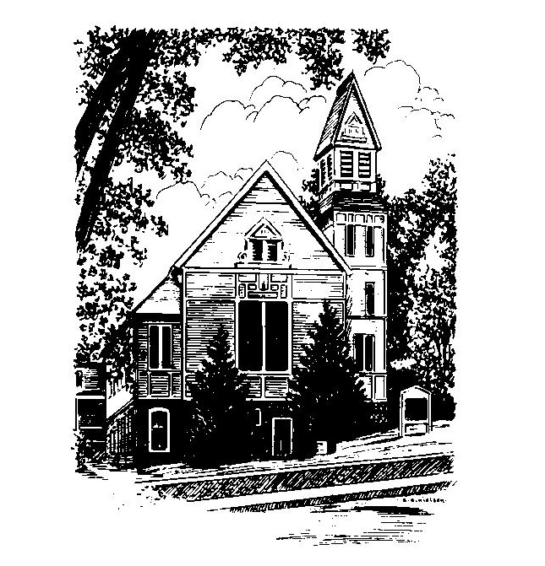
To Contact Us:
Church Office: 978-939-8821
Church website: www.baldwinvillecongochurch.org
Organist: Michelle Salvanelli
Videographer: Jeff Salvanelli
Church Wi-Fi password: Memorial 1874

Deacon of the Month: Nancy Heaney
Liturgist: Nancy Heaney
Our current supply preacher is Rev. Mike Scott.
Today: Coffee and conversation downstairs
COMMUNION TODAY
We take communion by intinction. We invite all who would share in Christ’s grace to come forward and take bread and dip it in the communion cup and eat with the blessing of Christ.
*denotes “All who are able please stand”. Masking is optional

Meditation Thought

“On All Saints' Day, it is not just the saints of the church that we should remember in our prayers, but all the foolish ones and wise ones, the shy ones and overbearing ones, the broken ones and whole ones, the despots and tosspots and crackpots of our lives who, one way or another, have been our particular fathers and mothers and saints, and whom we loved without knowing we loved them and by whom we were helped to whatever little we may have, or ever hope to have, of some kind of seedy sainthood of our own."
- Frederick Buechner

(Originally published in The Sacred Journey)

MEMORIAL CONGREGATIONAL CHURCH U.C.C. BALDWINVILLE, MA.
An Open and Affirming Church of
the United Church of Christ
November 5, 2023
No Matter Who You Are, No Matter Where
You Are on Life’s Journey; You Are Welcome Here!

PRELUDE

WELCOME

CALL TO WORSHIP

Leader: We come to this sanctuary surrounded by a great cloud of witnesses.
People: We come to run with perseverance the race that is set before us.
Leader: The Spirit calls on us to follow in the steps of our forebears in the faith.
People: Today, we remember them and rededicate ourselves to building up the church they loved, and furthering the ministry they bequeathed to us.
Leader: Come, let us worship.
People: Let us sing praise to the One who guides our feet and secures our future!

*HYMN Community of Christ Black Hymnal #314

Unison Prayer of Openness
Gathered in your name, O Spirit of Holiness, we ask that you would bless our worship, that in this hour we would be inspired by tradition, comforted by the familiar, awakened by the extraordinary, and challenged by your unbridled Spirit. Draw us into your presence and show us your way, we pray, in Jesus’ name. Amen.
*SHARING THE PEACE OF CHRIST
One: May the peace of Christ be with you!
Many: And also with you!
--Please “Pass the Peace” however you feel comfortable
as we sing Amen!
*AMEN (Sung twice) Red Hymnal #317
Amen, Amen, Amen, Amen, Amen

OFFERING OURSELVES AND OUR GIFTS
CALL TO GIVING
As our offering is brought forward let us sing:
Praise God, from whom all blessings flow;
Praise God, all creatures here below;
Alleluia! Alleluia!
Praise God above, you heavenly host;
Praise Father, Son, and Holy Ghost.
Alleluia! Alleluia! Alleluia!
Alleluia! Alleluia!
PRAYER OF DEDICATION

FIRST SCRIPTURE Psalm 8
SPECIAL MUSIC
SECOND SCRIPTURE Hebrews 1:1-4; 2:5-12
MESSAGE The Communion of Saints Mike Scott

*COMMUNION HYMN Bread of the World
Black Hymnal #346

SHARING OUR PRAYERS, OUR JOYS, OUR HOPES

A TIME OF REMEMBERANCE
(YOU ARE INVITED TO CALL OUT THE NAME OF SOMEONE
YOU WISH TO REMEMBER – THE CHURCH BELL WILL TOLL
AFTER EACH NAME)
SINGING TOGETHER For All the Saints
Black Hymnal #299
PASTORAL PRAYER
THE LORD’S PRAYER
Our father who art in heaven hallowed be thy name. Thy kingdom come thy will be done on earth as it is in heaven. Give us this day our daily bread and forgive us our trespasses as we forgive those who trespass against us. And lead us not into temptation but deliver us from evil. For thine is the kingdom and the power and the glory forever. Amen.
-Response (sung)
Hear our Prayer, O Lord, Hear our prayer O Lord.
Incline thine ear to us, and grant us thy peace. Amen

INVITATION TO THE TABLE
Everyone, of any age, who seeks Christ’s presence
is welcome at this table!.

WORDS OF INSTITUTION

DECLARATION:
Minister: And so, remembering what Christ has done for us,
we come to this table in thanksgiving and commitment,
affirming the ancient creed of our faith:
ALL: (Sung) Christ has died. Christ has Risen.
Christ will come again.

SHARING THE BREAD AND CUP

*HYMN: O, Savior, for the Saints Black Hymnal # 298

*BENEDICTION

POSTLUDE

