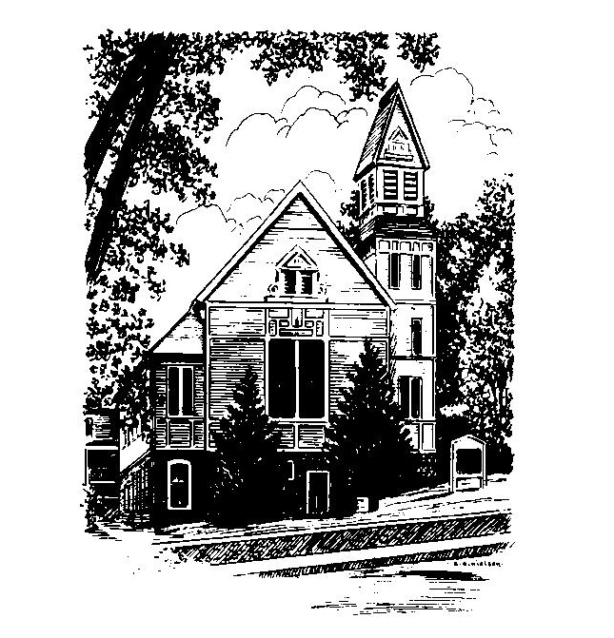
To Contact Us:
Church Office: 978-939-8821
Church website: www.baldwinvillecongochurch.org
Organist: Michelle Salvanelli
Videographer: Jeff Salvanelli
Church Wi-Fi password: Memorial 1874

Deacon of the Month: Joanne Francis
Liturgist: Nowell Francis
While we look for our way ahead as a church, we have a supply preacher each Sunday. Currently, and for the foreseeable future, our supply preacher is Rev. Mike Scott.
Today: Coffee and conversation downstairs
The Discernment Committee will meet after worship.
*denotes “All who are able please stand”. Masking is optional

Meditation Thought

A parable is a small story with a large point. Most of the ones Jesus told have a kind of sad fun about them. The parables of the Crooked Judge (Luke 18:1-8), the Sleepy Friend (Luke 11:5-8), and the Distraught Father (Luke 11:11-13) are really jokes in their way, at least part of whose point seems to be that a silly question deserves a silly answer. In the Prodigal Son (Luke 15:11-32), the elder brother's pious pique when the returning Prodigal gets the red-carpet treatment is worthy of Moliere’s Tartuffe, as is the outraged legalism of the Laborers in the Vineyard (Matthew 20:1-16) when Johnny-come-lately gets as big a slice of the worm as the early bird.
-Frederick Buechner
(originally published in Wishful Thinking
and later in Beyond Words)

MEMORIAL CONGREGATIONAL CHURCH U.C.C. BALDWINVILLE, MA.
An Open and Affirming Church of
the United Church of Christ
September 24, 2023
No Matter Who You Are, No Matter Where
You Are on Life’s Journey; You Are Welcome Here!

PRELUDE
WELCOME
CALL TO WORSHIP

Leader: Come, all who hunger and thirst for what is right,
and be satisfied.
People: Come; be refreshed by living water, that we
may never thirst again.
Leader: Come; be renewed by the Spirit, that being filled
we may minister to the hunger and thirst of others.
People: We come in worship and praise, that we might all
find the path to justice, refreshment, and renewal.

*OPENING HYMN: God, Whose Giving Knows No Ending
Red hymnal #606
Unison Prayer of Openness
Author of Life, we thank you for the seasons of this earth, for planting and sowing, for harvest and reaping. So also you give us seasons of the heart. Grant that in a drought of grace we may find your oasis of prayer. Grant that in a storm of grief we may find your shelter of faith. Grant that in the seasons of our days we may look within and find rich soil for your seeds of hope. In Christ’s name, we pray. Amen.

*SHARING THE PEACE OF CHRIST
One: May the peace of Christ be with you!
Many: And also with you!
--Please “Pass the Peace” however you feel comfortable
as we sing Amen!
*AMEN (Sung twice) Red Hymnal #317
Amen, Amen, Amen, Amen, Amen

OFFERING OURSELVES AND OUR GIFTS TO GOD
Call to Giving
*Offering and Doxology
(If you have not put you offering in the offering plate you may do so now)
--Our offering will be brought forward as we sing:
Praise God, from whom all blessings flow;
Praise God, all creatures here below;
Alleluia! Alleluia!
Praise God above, you heavenly host;
Praise Father, Son, and Holy Ghost.
Alleluia! Alleluia! Alleluia!
Alleluia! Alleluia!
*Prayer of Dedication
FIRST SCRIPTURE Jonah 3:10-4:11
SPECIAL MUSIC
SECOND SCRIPTURE Matthew 20:1-16
MESSAGE It’s Not Fair! Mike Scott

HYMN The Gift of Love Red Hymnal # 526

SHARING OUR PRAYERS, OUR JOYS, OUR HOPES

PASTORAL PRAYER
THE LORD’S PRAYER
Our father who art in heaven hallowed be thy name. Thy kingdom come thy will be done on earth as it is in heaven. Give us this day our daily bread and forgive us our trespasses as we forgive those who trespass against us. And lead us not into temptation but deliver us from evil. For thine is the kingdom and the power and the glory forever. Amen.
-Response (sung)
Hear our Prayer, O Lord, Hear our prayer O Lord.
Incline thine ear to us, and grant us thy peace. Amen

*HYMN: Lord, Whose Love Through Humble Service
Red Hymnal # 461

*BENEDICTION

POSTLUDE

