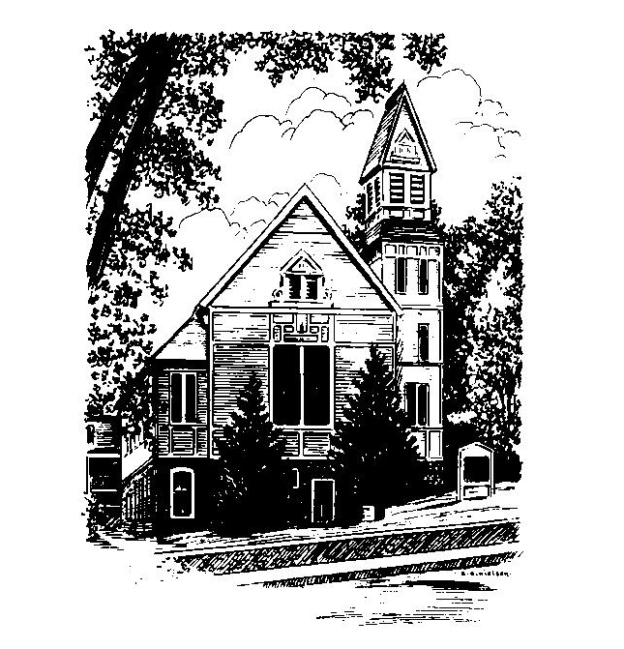
To Contact Us:
Church Office: 978-939-8821
Church website: www.baldwinvillecongochurch.org
Organist: Michelle Salvanelli
Videographer: Jeff Salvanelli
Church Wi-Fi password: Memorial 1874

Deacon of the Month: Joanne Francis
Liturgist: Joanne Francis
While we look for our way ahead as a church, we have a supply preacher each Sunday. Currently, and for the foreseeable future, our supply preacher is Rev. Mike Scott.
Today: Coffee and conversation downstairs
*denotes “All who are able please stand”. Masking is optional

Meditation Thought

In addition to the battle to "get ahead," there is another:

“THIS OTHER WAR is the war not to conquer but the war to become whole and at peace inside our skins. It is a war not of conquest now but of liberation because the object of this other war is to liberate that dimension of selfhood which has somehow become lost, that dimension of selfhood that involves the capacity to forgive and to will the good not only of the self but of all other selves. This other war is the war to become a human being. This is the goal that we are really after and that God is really after. This is the goal that power, success, and security are only forlorn substitutes for. This is the victory that not all our human armory of self-confidence and wisdom and personality can win for us—not simply to be treated as human but to become at last truly human.”
-Frederick Buechner
(Originally published in The Magnificent Defeat)

MEMORIAL CONGREGATIONAL CHURCH U.C.C. BALDWINVILLE, MA.
An Open and Affirming Church of
the United Church of Christ
September 17, 2023
No Matter Who You Are, No Matter Where
You Are on Life’s Journey; You Are Welcome Here!

PRELUDE
WELCOME
CALL TO WORSHIP

Leader: Sisters and brothers, we have come together to
worship the One who offers us freedom and grace.
People: For the Spirit has set us free to be the people
we are intended to be.
Leader: Let our worship be a celebration of the joyful unity
we find in the liberating power of that Spirit.
People: Let us worship in spirit and in truth!

*OPENING HYMN: We Cannot Own the Sunlit Sky
Red hymnal #684
Unison Prayer of Openness
Author of Creation and Wellspring of our life, we rejoice in your love which renews us each day and calls us to share in abundant life. We are thankful for Jesus who revealed most fully your loving purpose for all people. We celebrate your Spirit of Holiness that draws all humanity into your circle of love. Help us to be open to your presence in our lives and in our worship, that we might truly reflect your love in all we say and do. Amen.

*SHARING THE PEACE OF CHRIST
One: May the peace of Christ be with you!
Many: And also with you!
--Please “Pass the Peace” however you feel comfortable
as we sing Amen!
*AMEN (Sung twice) Red Hymnal #317
Amen, Amen, Amen, Amen, Amen

OFFERING OURSELVES AND OUR GIFTS TO GOD
Call to Giving
*Offering and Doxology
(If you have not put you offering in the offering plate you may do so now)
--Our offering will be brought forward as we sing:
Praise God, from whom all blessings flow;
Praise God, all creatures here below;
Alleluia! Alleluia!
Praise God above, you heavenly host;
Praise Father, Son, and Holy Ghost.
Alleluia! Alleluia! Alleluia!
Alleluia! Alleluia!
*Prayer of Dedication
FIRST SCRIPTURE Romans 14:1-12
SPECIAL MUSIC
SECOND SCRIPTURE Matthew 18:21-35
MESSAGE Different Strokes Mike Scott

HYMN Diverse in Culture, Nation, Race No. 485 Red
(To the tune: Maryton, No. 602 Red)

SHARING OUR PRAYERS, OUR JOYS, OUR HOPES

PASTORAL PRAYER
THE LORD’S PRAYER
Our father who art in heaven hallowed be thy name. Thy kingdom come thy will be done on earth as it is in heaven. Give us this day our daily bread and forgive us our trespasses as we forgive those who trespass against us. And lead us not into temptation but deliver us from evil. For thine is the kingdom and the power and the glory forever. Amen.
-Response (sung)
Hear our Prayer, O Lord, Hear our prayer O Lord.
Incline thine ear to us, and grant us thy peace. Amen

*HYMN: O for a World Red Hymnal # 683

*BENEDICTION

POSTLUDE

