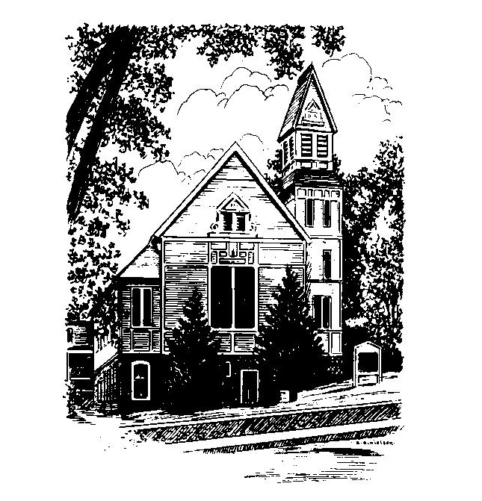
To Contact Us:
Church Office: 978-939-8821
Church website: www.baldwinvillecongochurch.org
Organist: Michelle Salvanelli
Videographer: Jeff Salvanelli
Church Wi-Fi password: Memorial 1874

Deacon of the Month: Barbara Woodbury
Liturgist: Barbara Woodbury
While we look for our way ahead as a church, we welcome supply preachers each Sunday. Today, our own Rev. Mike Scott is leading worship.
Today: Coffee and conversation downstairs
Today is our monthly collection of food for the Templeton Food Pantry. Thank you for helping others less fortunate.
This Sunday is the last Sunday we will be meeting down in the vestry. Next Sunday September 3, we will be in the sanctuary.
Rev. John Shaw, will be preaching next Sunday, September 3.
*denotes “All who are able please stand”. Masking is optional

Meditation Thought (about “The Kingdom of God”)

It is not a place, of course, but a condition. Kingship might be a better word. . . .As a poet, Jesus is maybe at his best in describing the feeling you get when you glimpse the Thing Itself—the kingship of the king official at last and all the world his coronation. It's like finding a million dollars in a field, he says, or a jewel worth a king's ransom. . . When the kingdom really comes, it's as if the thing you lost and thought you'd never find again is you.” -Frederick Buechner
(Originally published in Wishful Thinking)

MEMORIAL CONGREGATIONAL CHURCH U.C.C. BALDWINVILLE, MA.
An Open and Affirming Church of
the United Church of Christ
August 27, 2023
No Matter Who You Are, No Matter Where
You Are on Life’s Journey; You Are Welcome Here!

PRELUDE
WELCOME
CALL TO WORSHIP

Leader: Lord of the whirlwind and fire
sweeps into our presence in this hour.
People: Glory be to the Highest,
who strengthens us and blesses all people
with peace.
Leader: The One who called all worlds into being
calls forth new life in us today.
People: Glory be to the Highest,
in whose creative purpose we are claimed
and empowered.
Leader: The One whose Spirit unites all people
in a common language of love,
confirms the Spirit’s gifts in us as we gather here.
People: Glory be to the Highest,
in whose light we can walk in confident
expectation.

*OPENING HYMN: Joyful, Joyful, We Adore Thee
Red hymnal #2
OPENING PRAYER (unison) Source of Being and Genesis of Love, who knows our hearts and resides in the fabric of the universe, increase our faith as we, your people, gather in worship. Help us to know and receive the gifts of your Spirit. Grace us, we pray, with your abounding love, joy, peace, and patience. Fill us with kindness, faithfulness, gentleness, and self-control. So strengthened in faith, may we share your generosity with all the world. Amen.

*SHARING THE PEACE OF CHRIST
One: May the peace of Christ be with you!
Many: And also with you!
--Please “Pass the Peace” however you feel comfortable
as we sing Amen!
*AMEN (Sung twice) Red Hymnal #317
Amen, Amen, Amen, Amen, Amen

OFFERING OURSELVES AND OUR GIFTS TO GOD
Call to Giving
*Offering and Doxology
(If you have not put you offering in the offering plate you may do so now)
--Our offering will be brought forward as we sing:
Praise God, from whom all blessings flow;
Praise God, all creatures here below;
Alleluia! Alleluia!
Praise God above, you heavenly host;
Praise Father, Son, and Holy Ghost.
Alleluia! Alleluia! Alleluia!
Alleluia! Alleluia!
*Prayer of Dedication
FIRST SCRIPTURE Genesis 1: 1-5
SPECIAL MUSIC
SECOND SCRIPTURE 1 John 4:7-16
MESSAGE The Frog Prince Mike Scott

HYMN Amazing Grace
Red Hymnal #546

SHARING OUR PRAYERS, OUR JOYS, OUR HOPES

PASTORAL PRAYER
THE LORD’S PRAYER
Our father who art in heaven hallowed be thy name. Thy kingdom come thy will be done on earth as it is in heaven. Give us this day our daily bread and forgive us our trespasses as we forgive those who trespass against us. And lead us not into temptation but deliver us from evil. For thine is the kingdom and the power and the glory forever. Amen.
-Response (sung)
Hear our Prayer, O Lord, Hear our prayer O Lord.
Incline thine ear to us, and grant us thy peace. Amen

*HYMN: They’ll Know We Are Christians
Red Hymnal # 494

*BENEDICTION

POSTLUDE

