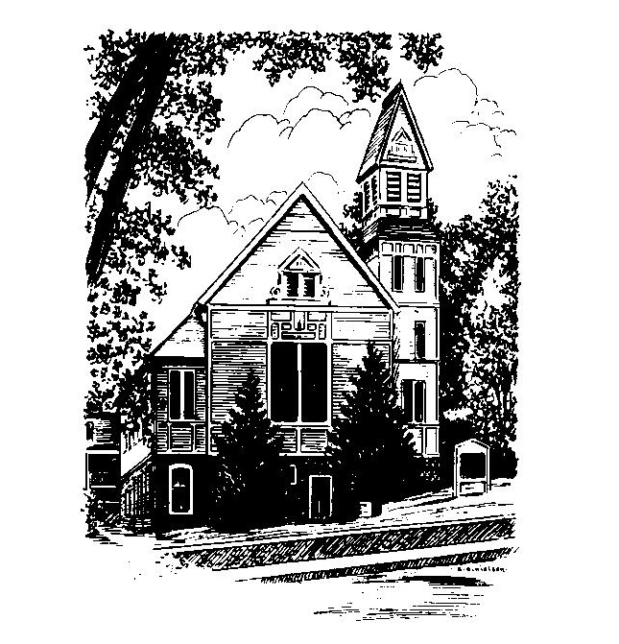
To Contact Us:
Church Office: 978-939-8821
Church website: www.baldwinvillecongochurch.org
Organist: Michelle Salvanelli
Videographer: Jeff Salvanelli
Church Wi-Fi password: Memorial 1874

Deacon of the Month: Barbara Woodbury
Liturgist: Sandy Skinner
While we look for our way ahead as a church, we welcome supply preachers each Sunday. Today, our own Rev. Mike Scott is leading worship
Today: Coffee and conversation downstairs
We are now collecting canned goods & food for the Food
Pantry
*denotes “All who are able please stand”.
Masking is optional for worship.
Meditation Thought
“The love for equals is a human thing--of friend for friend, brother for brother. It is to love what is loving and lovely. The world smiles. The love for the less fortunate is a beautiful thing--the love for those who suffer, for those who are poor, the sick, the failures, the unlovely. This is compassion, and it touches the heart of the world. The love for the more fortunate is a rare thing--to love those who succeed where we fail, to rejoice without envy with those who rejoice, the love of the poor for the rich, of the black man for the white man. The world is always bewildered by its saints. And then there is the love for the enemy--love for the one who does not love you but mocks, threatens, and inflicts pain. The tortured's love for the torturer. This is God's love. It conquers the world.”
― Frederick Buechner, The Magnificent Defeat

MEMORIAL CONGREGATIONAL CHURCH U.C.C. BALDWINVILLE, MA.
An Open and Affirming Church of
the United Church of Christ
August 20, 2023
No Matter Who You Are, No Matter Where
You Are on Life’s Journey; You Are Welcome Here!

PRELUDE
WELCOME
CALL TO WORSHIP
Leader: Let us journey together in faith.
Bring hearts that are open to others;
Bring minds that are open to new ideas;
Bring spirits that are open to the Spirit’s leading.
People: We are called into an uncertain future.
Leaving the securities to which we cling;
Leaving the things that possess us;
Leaving the certainty of our assumptions.
Leader: Let us travel together, hand in hand.
People: We rejoice in the promise of divine grace!

*OPENING HYMN: Stars and Planets Flung in Orbit
Black hymnal # 567
OPENING PRAYER (unison) We come before you, O Holy One, with gratitude for the universal gift of love. As Jesus came long ago to reveal your love and grace, so may we seek him still today in our spiritual journeys. Give us courage to follow him over rocky hills where we carry crosses, and green valleys where you restore our souls. May we find ourselves bound to each other in love. We pray this in the name of the shepherd who gave his life for the sheep. Amen.

*SHARING THE PEACE OF CHRIST
One: May the peace of Christ be with you!
Many: And also with you!
--Please “Pass the Peace” however you feel comfortable
as we sing Amen!
*AMEN (Sung twice) Red Hymnal #317
Amen, Amen, Amen, Amen, Amen

OFFERING OURSELVES AND OUR GIFTS TO GOD
Call to Giving
*Offering and Doxology
(If you have not put you offering in the offering plate you may do so now)
--Our offering will be brought forward as we sing:
Praise God, from whom all blessings flow;
Praise God, all creatures here below;
Alleluia! Alleluia!
Praise God above, you heavenly host;
Praise Father, Son, and Holy Ghost.
Alleluia! Alleluia! Alleluia!
Alleluia! Alleluia!
*Prayer of Dedication

FIRST SCRIPTURE Genesis 1: 1-5
SPECIAL MUSIC
SECOND SCRIPTURE 1 John 4:7-16

MESSAGE Who Knew? Mike Scott
(Thoughts on Oneness and Love)

HYMN God, Who Stretched the Spangled Heavens
Black Hymnal #556

SHARING OUR PRAYERS, OUR JOYS, OUR HOPES

PASTORAL PRAYER
THE LORD’S PRAYER
Our father who art in heaven hallowed be thy name. Thy kingdom come thy will be done on earth as it is in heaven. Give us this day our daily bread and forgive us our trespasses as we forgive those who trespass against us. And lead us not into temptation but deliver us from evil. For thine is the kingdom and the power and the glory forever. Amen.
-Response (sung)
Hear our Prayer, O Lord, Hear our prayer O Lord.
Incline thine ear to us, and grant us thy peace. Amen

*HYMN: O Love That Will Not Let Me Go
Black Hymnal # 485

*BENEDICTION

POSTLUDE

