One: Go in peace
All: In the knowledge of God’s power
One: Go in peace
All: In the knowledge of God’s strength
One: Go in joy
All: In the knowledge of God’s love
POSTLUDE
To Contact Us:
Church Office: 978-939-8821
Church website: www.baldwinvillecongochurch.org
Preaching today: Noelle Dattilo
Organist: Michelle Salvanelli
Videographer: Jeff Salvanelli
Church wi-fi password: Memorial 1874

Deacon of the Month: Nancy Heaney
Liturgist:
Coffee Hour after church service -downstairs

We are now collecting canned goods & food for the Food
Pantry
*denotes “All who are able please stand”.
© 2017 Joan Stott –‘The Timeless Psalms’ RCL Psalms Year A. Based on verses from Psalm 23. Used with permission.

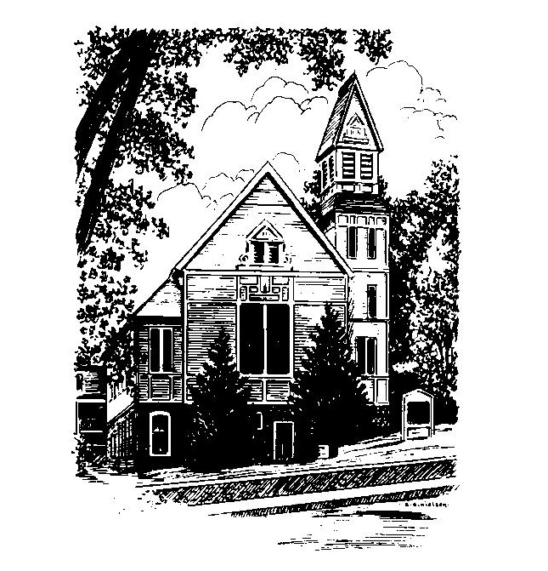
MEMORIAL CONGREGATIONAL CHURCH
U.C.C. BALDWINVILLE, MA.
An Open and Affirming Church of
the United Church of Christ
July 9, 2023

No Matter Who You Are, No Matter Where You Are
on Life’s Journey; You Are Welcome Here!
PRELUDE:
WELCOME:
CALL TO WORSHIP
God of hope, we come together from our isolation to share in worship of you.
Gentle Shepherd, you carry the vulnerable ones in his arms, so we thank you.
God of comfort, we come together with our own pain and regrets, to praise you.
Tender Shepherd of all the sheep and goats, we come to receive your blessings.
God of new beginnings, we come together in trust, faith and hope to share in a
community, where worship of God is central to our spiritual nurture and growth.
Welcoming Shepherd of the sheepfold, you never turn your back on us, but invite
us into your Holy Presence for the healing of our wounds and to meet all our
needs - while offering us compassionate care; and so we revere your Holy Name. Amen.

*OPENING HYMN: There's a Wideness in God's Mercy
Back hymnal #417

OPENING PRAYER: (unison) Lord of Love and Light, shine through our darkness, bringing us hope. Open our hearts for the journey, our eyes for the light, our spirits for the peace which you bring. Fill our mouths with laughter and speech with shouts of joy that we shall reveal the love with which you surround us. We offer this prayer in the name of the One who is coming into the world bringing your hope, love, peace, and joy, Jesus Christ. Amen.

*SHARING THE PEACE OF CHRIST
One: May the peace of Christ be with you!
Many: And also with you!
--Please “Pass the Peace” however you feel comfortable as we
sing Amen!
*AMEN (Sung twice) Red Hymnal #317
Amen, Amen, Amen, Amen, Amen

OFFERING OURSELVES AND OUR GIFTS TO GOD: --Our offering will be brought forward as we sing: ( If you have not put you offering in the offering plate you may do so now)
Praise God, from whom all blessings flow;
Praise God, all creatures here below;
Alleluia! Alleluia!
Praise God above, you heavenly host;
Praise Father, Son, and Holy Ghost.
Alleluia! Alleluia! Alleluia!
Alleluia! Alleluia!
The tune with different words may be found in the Red Hymnal #22

*DEDICATION Gracious God, everything we have comes from you. You fill us with good things. Our hearts and lives overflow with your abundance. With thanksgiving we bring to you our time, talents and tithes. Use these gifts that you have given us to feed others as we have been fed, to serve others as we have been served, and to bless others as we have been blessed. Amen.
FIRST SCRIPTURE: Psalm 23
SPECIAL MUSIC:
SECOND SCRIPTURE: Luke 8:26-39
SERMON: The Power of God to Heal
HYMN God is My Shepherd Black Hymnal #479
SHARING OUR PRAYERS, OUR JOYS, OUR HOPES -PASTORAL PRAYER
THE LORD’S PRAYER : Our father who art in heaven hallowed be thy name. Thy kingdom come thy will be done on earth as it is in heaven. Give us this day our daily bread and forgive us our trespasses as we forgive those who trespass against us. And lead us not into temptation but deliver us from evil. For thine is the kingdom and the power and the glory forever. Amen.

Response (sung)
Hear our Prayer, O Lord, Hear our prayer O Lord.
Incline thine ear to us, and grant us thy peace. Amen

*HYMN God's Eye in On the Sparrow
Black Hymnal # 475
*SENDING FORTH:

