To Contact Us:
Church Office: 978-939-8821
Church website: www.baldwinvillecongochurch.org
Rev. Richard A. Jones -413-283-4440
Revraj@aol.com
Organist: Michelle Salvanelli
Videographer: Jeff Salvanelli
Church wi-fi password: Memorial 1874

Deacon of the Month: Barbara Woodbury
Liturgist: Barbara Woodbury
Today: Marjorie Whittemore officially rejoins Memorial Church,
having been a part of the church some years back.
Coffee Hour after church service -downstairs

We are now collecting canned goods & food for the Food
Pantry
*denotes “All who are able please stand”.
Meditation Thought
“The true opposite of depression is neither gaiety nor absence of pain, but vitality—the freedom to experience spontaneous feelings. It is part of the kaleidoscope of life that these feelings are not only happy, beautiful, or good but can reflect the entire range of human experience, including envy, jealousy, rage, disgust, greed, despair, and grief.”
Alice Miller, The Drama of the Gifted Child: The Search for the True Self
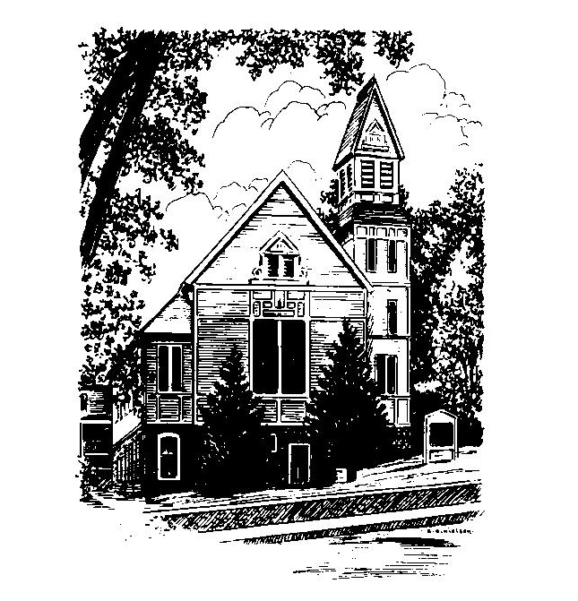
MEMORIAL CONGREGATIONAL CHURCH
U.C.C. BALDWINVILLE, MA.
An Open and Affirming Church of
the United Church of Christ
June 11, 2023
Second Sunday of Pentecost
No Matter Who You Are, No Matter Where You Are
on Life’s Journey; You Are Welcome Here!
PRELUDE:
WELCOME:
CALL TO WORSHIP
One: “God saw everything that he had made, and indeed it
was very good.”
ALL: We give thanks for creation’s bounty and its beauty.
One: “And on the seventh day God rested from all the work that
he had done in creation.”
ALL: For labor and for rest we give you thanks, O God;
sustain us in your creative energy and free us from
compulsive doing that we may rest in your grace.
One: “God blessed the seventh day and hallowed it, because
on it God rested.”
ALL: Teach us the wisdom of Sabbath o God, and bring
us into deeper union with you.
*OPENING HYMN: All Creatures of Our God & King
Red hymnal #22
OPENING PRAYER: (unison) O God, as we prepare for the warmth of summer we are reminded of the cool balm of your grace and pray that your spirit might inspire us for the challenges that lie ahead: be the healing and the renewing in us. Let us rest in your promises even as we strive for the wisdom to make our lives and our world closer to the dream you have for us. Let your spirit guide us towards our best future and have the vision and the steadiness of heart to make it so. Amen.
*SHARING THE PEACE OF CHRIST
One: May the peace of Christ be with you!
Many: And also with you!
--Please “Pass the Peace” however you feel comfortable as we
sing Amen!
*AMEN (Sung twice) Red Hymnal #317
Amen, Amen, Amen, Amen, Amen
SERVICE FOR RECEIVING NEW MEMBERS (insert)
OFFERING OURSELVES AND OUR GIFTS TO GOD: --Our offering will be brought forward as we sing: ( If you have not put you offering in the offering plate you may do so now)
Praise God, from whom all blessings flow;
Praise God, all creatures here below;
Alleluia! Alleluia!
Praise God above, you heavenly host;
Praise Father, Son, and Holy Ghost.
Alleluia! Alleluia! Alleluia!
Alleluia! Alleluia!
The tune with different words may be found in the Red Hymnal #22
*DEDICATION: We stand before you again, O God of mystery and wonder, with these offerings and we commit ourselves anew to be a community in service to you and to the world in the name of that one Jesus. Use these offerings to bring your light and your healing more truly into the world we pray. Amen
FIRST SCRIPTURE: Hosea 6:1 - 6
SPECIAL MUSIC:
SECOND SCRIPTURE: Matthew: 9 – 13 & 18 -26
SERMON: Three Desperate People
HYMN: We Cannot Own the Sunlit Sky Red Hymnal # 684
SHARING OUR PRAYERS, OUR JOYS, OUR HOPES --PASTORAL PRAYER
THE LORD’S PRAYER : Our father who art in heaven hallowed be thy name. Thy kingdom come thy will be done on earth as it is in heaven. Give us this day our daily bread and forgive us our trespasses as we forgive those who trespass against us. And lead us not into temptation but deliver us from evil. For thine is the kingdom and the power and the glory forever. Amen.
-Response (sung)
Hear our Prayer, O Lord, Hear our prayer O Lord.
Incline thine ear to us, and grant us thy peace. Amen

*HYMN: How Great Thou Art Red Hymnal # 33
*SENDING FORTH:
One: Go from this place to live your faith in the world.
ALL We go from this place seeking, with God’s help, to live
the faith we proclaim and to uphold God’s love for all
the world.
One: May God bless you and keep you in God’s unfaltering
grace.
ALL: And you also. Amen.

POSTLUDE

