To Contact Us:

Church Office: 978-939-8821
Church website: www.baldwinvillecongochurch.org
Minister: Rev. Richard A. Jones -413-283- 4440
E-mail Revraj@aol.com
Organist: Michelle Salvanelli
Vidiographer: Jeff Salvanelli
Church WiFi password: Memorial 1874

Deacon of the Month: Barbara Woodbury

Reader Today: Barbara Woodbury

ANNOUNCEMENTS
COMMUNION TODAY
We take communion by intinction. We invite all who would share in Christ’s grace to come forward and take bread and dip it in the communion cup and eat with the blessing of God.

Today: Coffee Hour after church + Discernment Committee

Meditation Thought
What is addiction, really? It is a sign, a signal, a symptom of distress. It is a language that tells us about a plight that must be understood.”
― Alice Miller, Breaking Down the Wall of Silence: The Liberating Experience of Facing Painful Truth

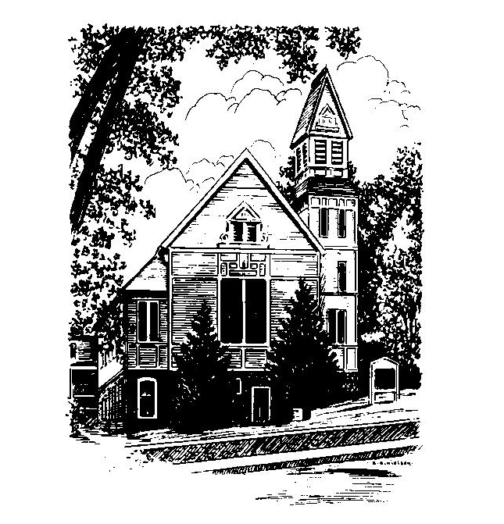
MEMORIAL CONGREGATIONAL
CHURCH U.C.C.
Baldwinville
An Open and Affirming Church of the United
Church of Christ
June 4, 2023 10:00 AM
Trinity Sunday
No Matter Who You Are, No Matter Where You Are on Life’s
Journey, You Are Welcome Here!
PRELUDE:
WELCOME
CALL TO WORSHIP
One: God is Spirit.
ALL: They that worship God must worship in Spirit and in
Truth.
One: God’s truth is in the wisdom of the open heart. God’s Spirit
lifts up the mystery of grace and the power of redemption.
ALL
.: We come as seekers of God’s Truth: we come to
open heart, soul and mind before the Eternal One.
One: Let us give thanks then, and commit ourselves anew to
work for God’s purposes in our time even as we receive
God’s sacrament of Grace.
ALL: We rejoice in God always and seek to let God’s Spirit
fill our hearts and guide our lives.

*OPENING HYMN: Rise Up O Saints Red Hymnal # 611
OPENING PRAYER: (unison) O Lord, in this season of newness and green, we gather again seeking your grace. Wherever life has begun to overwhelm us, and dreariness has become our companion, touch our souls with your life renewing spirit. Let us feel the power of your presence and give us new strength for the tasks that are ahead. Wherever we have embraced resentment or bitterness, teach us the power of forgiveness, for ourselves and for others. Help us to sense anew the joy of your call and your readiness to embrace us fill us with the hope you have for us. Amen.

*SHARING THE PEACE OF CHRIST
One: May the peace of Christ be with you!
Many: And also with you!

*AMEN (Sung twice): Red Hymnal #317
OFFERING OURSELVES AND OUR GIFTS TO GOD:
As you bring your offering let us sing together:
Praise God, from whom all blessings flow;
Praise God, all creatures here below;
Alleluia! Alleluia!
Praise God above, you heavenly host;
Praise Father, Son, and Holy Ghost.
Alleluia! Alleluia! Alleluia!
Alleluia! Alleluia!

*DEDICATION: Holy God, we bring something of what we are, something of what we hope to be, and lay it on your altar. Let your life-renewing Spirit move in us and in your church that we may bear witness to your love amidst this troubled world. Let these offerings build a ministry of hope and a church that nurtures all who come here. Amen.

FIRST SCRIPTURE: Psalm 8
SPECIAL MUSIC
SECOND SCRIPTURE: Matthew 28: 16 -20
SERMON MEDITATION: But Some Doubted
*COMMUNION HYMN: Be Known to Us in Breaking Bread
0 Red hymnal # 398

SHARING OUR PRAYERS, OUR JOYS, OUR HOPES --PASTORAL PRAYER
THE LORD’S PRAYER –Our father who art in heaven hallowed be thy name. Thy kingdom come thy will be done on earth as it is in heaven. Give us this day our daily bread and forgive us our trespasses as we forgive those who trespass against us. And lead us not into temptation but deliver us from evil. For thine is the kingdom and the power and the glory forever. Amen.
-Response (sung)
Hear our Prayer, O Lord, Hear our prayer O Lord.
Incline thine ear to us and grant us thy peace.
INVITATION TO THE TABLE
Everyone, of all ages, who seeks God’s presence is welcome at this table!.
WORDS OF INSTITUTION -Minister
DECLARATION:
Minister: And so, remembering what Christ has done for us, we
come to this table in thanksgiving and commitment, affirming
the ancient creed of our faith:
ALL:(Sung) Christ has died. Christ has Risen. Christ will
come again.
SHARING THE BREAD AND CUP
*HYMN: O Master Let Me Walk With Thee
Red hymnal # 602
*SENDING FORTH:
One: The One who changes water into wine brings the ferment
of newness to our lives. Go from this place and know the
grace of God to make all things new!
All: We go opening ourselves to God’s Spirit and seeking
God’s grace to bring newness to our lives and to our
world. Amen.
POSTLUDE:

