To Contact Us:
Church Office: 978-939-8821
Church website: www.baldwinvillecongochurch.org
Rev. Richard A. Jones -413-283-4440
Revraj@aol.com
Organist: Michelle Salvanelli
Videographer: Jeff Salvanelli
Church wi-fi password: Memorial 1874

Deacon of the Month: Barbara Woodbury
Liturgist: Barbara Woodbury
Coffee Hour after church service -downstairs
Monday -Juneteenth – Celebrating the end of Slavery

We are now collecting canned goods & food for the Food
Pantry
*denotes “All who are able please stand”.
Meditation Thought
“Fundamentalism is patriarchy gone berserk. It is banishment of the mother in all of us and in our traditions. It results in mysticism repressed and denied, and it always leads to scapegoating—the projected hatred of others.”
Matthew Fox, -The Coming of the Cosmic Christ

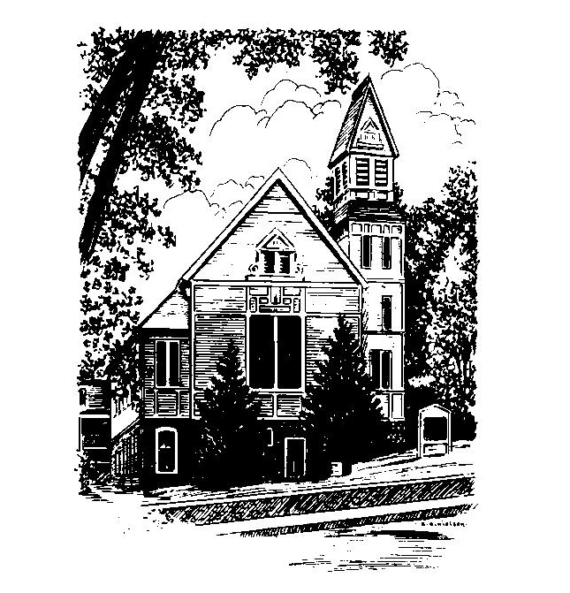
MEMORIAL CONGREGATIONAL CHURCH
U.C.C. BALDWINVILLE, MA.
An Open and Affirming Church of
the United Church of Christ
June 18, 2023
Third Sunday after Pentecost
Fathers Day
No Matter Who You Are, No Matter Where You Are
on Life’s Journey; You Are Welcome Here!
PRELUDE:
WELCOME:
CALL TO WORSHIP
One: We come from our individual journeys and our various
families to this sanctuary where together we seek to follow
God’s call in a journey of faith.
All: We join in common aspirations to make God’s grace
more real in our world and in our lives.
One We come seeking the healing presence of God and
God’s blessing for each and every family.
All: We gather here as disciples of the Risen Christ and
celebrate the ways we feel God’s love.

*OPENING HYMN: The God of Abraham Praise
Red hymnal #24
OPENING PRAYER: (unison) Holy God, we come again claiming the best of what it means to call you Heavenly Father, as we seek to truly live as your spiritual children. We rest in your fathering and mothering, thankful for an embrace that knows no bounds. Continue to hold us in your care, we pray, and draw us into such a relationship with you that our lives may be truer, our purposes clearer, our courage greater, our faith deeper and our ow8n ability to nurture our families and our world stronger. In Jesus’ name. Amen.
*SHARING THE PEACE OF CHRIST
One: May the peace of Christ be with you!
Many: And also with you!
--Please “Pass the Peace” however you feel comfortable as we
sing Amen!
*AMEN (Sung twice) Red Hymnal #317
Amen, Amen, Amen, Amen, Amen
OFFERING OURSELVES AND OUR GIFTS TO GOD: --Our offering will be brought forward as we sing: ( If you have not put you offering in the offering plate you may do so now)
Praise God, from whom all blessings flow;
Praise God, all creatures here below;
Alleluia! Alleluia!
Praise God above, you heavenly host;
Praise Father, Son, and Holy Ghost.
Alleluia! Alleluia! Alleluia!
Alleluia! Alleluia!
The tune with different words may be found in the Red Hymnal #22
*DEDICATION: Eternal God we bring this offering as we bring ourselves, humbly and with thanksgiving for all you have given us. We pray that through it, as through us, your church might be strengthened, its mission enabled, and its vision of justice, mercy, and renewal made more real in our lives and our world. Amen.
FIRST SCRIPTURE: Genesis 18: 1 -15
SPECIAL MUSIC:
SECOND SCRIPTURE: Matthew 9: 35- 10:8
SERMON: Eavesdropping on the Promises
HYMN: Dear Lord and Father of Mankind Red Hymnal #594
SHARING OUR PRAYERS, OUR JOYS, OUR HOPES --PASTORAL PRAYER
THE LORD’S PRAYER : Our father who art in heaven hallowed be thy name. Thy kingdom come thy will be done on earth as it is in heaven. Give us this day our daily bread and forgive us our trespasses as we forgive those who trespass against us. And lead us not into temptation but deliver us from evil. For thine is the kingdom and the power and the glory forever. Amen.
-Response (sung)
Hear our Prayer, O Lord, Hear our prayer O Lord.
Incline thine ear to us, and grant us thy peace. Amen

*HYMN: Stand By Me Red Hymnal #629
*SENDING FORTH:
One: May God bless your homes and your lives with peace and
love and purpose.
ALL: We rejoice in God’s grace with thanksgiving for life
and all God’s gifts.
One God has called you to be the church know that God is with
you.
ALL As we celebrate God’s grace, we commit ourselves
anew to faithful living as part of the people of God.
Amen!

POSTLUDE

