“Religion itself cannot but be dynamic which is why "return" is an incorrect term. A return to the forms of religion which perhaps existed a couple of centuries ago is absolutely impossible. On the contrary, in order to combat modern materialistic mores, as religion must, to fight nihilism and egotism, religion must also develop, must be flexible in its forms, and it must have a correlation with the cultural forms of the epoch.”
Aleksandr Solzhenitsyn

MEMORIAL
CONGREGATIONAL
CHURCH
U.C.C.
Baldwinville, Mass.

An Open and Affirming Church of
the United Church of Christ
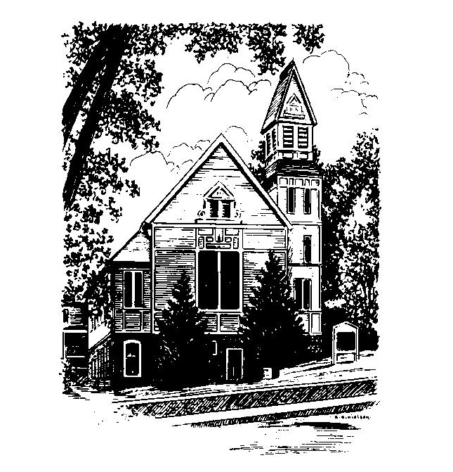

May 28, 2018
Pentecost Sunday
Confirmation
Memorial Day

No Matter Who You Are,
No Matter Where You Are on Life’s Journey,
You Are Welcome Here!
WELCOME
Welcome to our first-time guests!
Welcome to those who have no church home, need strength, have doubt, want to follow Christ, or even do not believe. Welcome to those who have more questions than answers or aren't sure where they are on their journey of faith!
Welcome to those who were baptized here and have worshiped in this place for generations!
Welcome to people of all sexual orientations & gender identities, to people of all racial & ethnic heritages, and to families of every shape and size!
May God find you where you are
and welcome you home

PRELUDE:
(Please note that some use this time for silent meditation)

WELCOME AND ANNOUNCEMENTS

CALL TO WORSHIP
One: God’s Spirit calls us here, to praise and reflect and to
know God’s grace and God’s calling.
All: God’s Spirit is the breath of life; it moves us to
rejoice and calls us to be a people of faith giving
thinks for God’s gifts embracing God’s hope for the
world.
One: God’s Spirit is the force of creation and the fire of
hope.
All: God’s Spirit urges and renews; it calls the church
into being and sends us out into the world.
One: God’s Spirit is still speaking, still calling for the church
to go forth in grace and minister to a broken world.

To Contact Us:
Church Office: 978-939-8821
Church website: www.mccbaldwinville.com
Church e-mail: pastor@mccbaldwinville.com
Organist Michelle Salvannelli
978-632-4901
The Rev. Richard A. Jones, Minister
Tel: 413- 283- 4440
Revraj@aol.com

Deacon for May Lei Messer

Liturgist Today: Noiwell Frances

Today: Coffee Hour reception for our Confirmand after
church

*DEDICATION:
Holy God, we come knowing that you ask first and foremost for our selves to be given, our lives in harmony with your truth and your grace, but we also come bringing these symbols of ourselves, our work, our time, our industry that we might share in the mission of Christ and be true disciples. Use who we are and what we have given in true service we pray. Amen.

FIRST READING: Acts 2: 1 -21

SPECIAL MUSIC:

SECOND LESSON : First Corinthians 12: 4 -13
.000000
SERVICE OF CONFIRM1023.
ATION
Today, Matthew Wendell Spivey who grew up in our church comes for the rite of Confirmation.
We rejoice with his family as he affirms the baptismal vows taken on his behalf and he assumes the rights and responsibilities of membership in the church.

SERVICE OF CONFIRMATION

Some thoughts on Confirmation and general reflections
–Rev Jones
Confirmation Vows: (confirmand stand)
Minister: I ask you then Matthew, do you come
expressing your faith in God, and in Jesus Christ as
God’s Word made Flesh and in the Holy Spirit as God’s
continuing presence, supporting and nurturing us
towards the mission of the church.
Confirmand: I Do.
Minister : And do you come committing yourself, with
the grace of God, to be Christ’s disciple as a member of
Memorial Church, sharing in its work and sacraments?
Confirmand: I do, with the help of God.
Minister: Will you then unite in covenant with this church
and all who seek to build the love of God in their lives
and in the world?
Confirmand: God being my helper and my guide I will.
Minister: Will you who are members of Memorial Church,
and members of the larger Christian family, continue to
nurture and embrace this young man and hold him in
your prayers as he goes forward in faith in his life
journey?
Congregation: We will God being our helper.
Laying on of hands and prayer of confirmation for our
confirmand.
UNISON PRAYER: O God, let your blessing be with Matthew, guide his life, strengthen his purposes, and grant him your grace as he goes forward in the adventure that will be his life.

PRESENTATION OF CERTIFICATE

*HYMN: I Was There to Hear Your Borning Cry
Red hymnal #75

SHARING OUR PRAYERS, OUR JOYS AND SORROWS

PASTORIAL PRAYER

LORD’S PRAYER (said in unison) Our Father, who art in heaven, hallowed be thy name. Thy kingdom come. Thy will be done on earth as it is in heaven. Give us this day our daily bread. And forgive us our trespasses as we forgive those who trespass against us. And lead us not into temptation, but deliver us from evil. For thine is the kingdom, and the power, and the glory, forever. Amen.

(Sung): tune may be found on #306 -Red Hymnal
Hear our Prayer, O Lord, Hear our prayer O Lord.
Incline thine ear to us, and grant us thy peace.

*CLOSING HYMN: Eternal Father Strong to Save
Red hymnal # 85
*SENDING FORTH:
One: Go forth from this place and let God’s love fill your
hearts, minds and souls and God’s spirit empower your
lives.
ALL: We seek to live in God’s Spirit and have God’s
Spirit live in us.
One: May God give you peace in your heart and strength in
your convictions to fulfill Christ’s call and be all that God
has given you wisdom and strength to become.
ALL: May it ever be so!.

POSTLUDE:

All: May God’s Spirit open our eyes and our hearts to
see and know the fullness and the joy of God’s
calling.
*OPENING HYMN: On Pentecost They Gathered
Red hymnal #237
OPENING PRAYER: (unison)
O Lord on this day as we celebrate your Spirit infusing and inspiring the Church and remember those who gave themselves so unselfishly in service to country, as well as look forward to affirming your spirit in one of our young people, we ask that your grace might inspire us anew. Grant us a greater sense of your calling and the urging of your spirit to the fullness of faith that we might find joy in our lives and meaning in our work together. Amen

*SHARING THE PEACE OF CHRIST
One: May the peace of Christ be with you!
Many: And also with you!

*AMEN (Sung twice): Red Hymnal #317
Amen, Amen,
Amen, Amen, Amen.
OFFERING OURSELVES AND OUR GIFTS TO GOD:
You are invited to bring forward your offering while we sing together:
Praise God, from whom all blessings flow;
Praise God, all creatures here below;
Alleluia! Alleluia!
Praise God above, you heavenly host;
Praise Father, Son, and Holy Ghost.
Alleluia! Alleluia! Alleluia!
Alleluia! Alleluia!

