To Contact Us:

Church Office: 978-939-8821
Church website: www.baldwinvillecongochurch.org
Minister: Rev. Richard A. Jones -413-283- 4440
E-mail Revraj@aol.com
Organist: Michelle Salvanelli
Vidiographer: Jeff Salvanelli
Church WiFi password: Memorial 1874

Deacon of the Month: Lei Messer
Reader Today Lei Messer

ANNOUNCEMENTS
COMMUNION TODAY
We take communion by intinction. We invite all who would share in Christ’s grace to come forward and take bread and dip it in the communion cup and eat with the blessing of God.

Today: Coffee Hour +Confirmation after church

Wed. April 19, 6:30 -Ames More Guild
Meditation Thought
“Many people suffer all their lives from this oppressive feeling of guilt, the sense of not having lived up to their parents' expectations. This feeling is stronger than any intellectual insight they might have, that it is not a child's task or duty to satisfy his parents’ needs. No argument can overcome these guilt feelings, for they have their beginnings in life's earliest periods, and from that they derive their intensity and obduracy.”
― Alice Miller, (Swiss psychologist, psychoanalyst and philosopher) The Drama of the Gifted Child: The Search for the True Self --

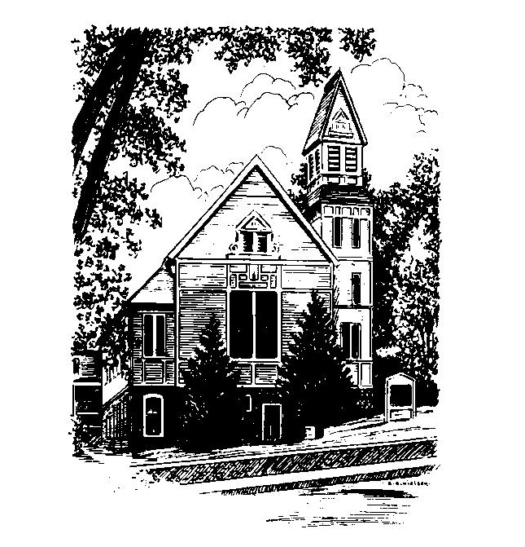
MEMORIAL CONGREGATIONAL
CHURCH U.C.C.
Baldwinville
An Open and Affirming Church of the United
Church of Christ
May 7, 2023 10:00 AM
Fifth Sunday of Easter
No Matter Who You Are, No Matter Where You Are on Life’s
Journey, You Are Welcome Here!
PRELUDE:
WELCOME
CALL TO WORSHIP
ONE: We gather from all those places of joy and sorrow, hope
and worry that make up our lives.
ALL: We come to lay all that we are before the God of life
and celebrate the gift of grace that embraces us.
ONE: God promises that if we live in faith and ground
ourselves in God’s love, God will strengthen us in all our
endeavors and guide us towards our best hopes.
ALL: We come giving thanks for God’s sustaining presence
and commit ourselves anew to be disciples of Jesus as
we take in God’s grace.

*OPENING HYMN: Praise to the Lord Red Hymnal # 25
OPENING PRAYER: (unison) O God of Resurrection, you reveal yourself in so many hidden and miraculous ways; teach us to see the wonder of life in each new bud of spring, to marvel at butterfly wings, wildflower fields and the growth of new green wood. Where we let disappointments stagnate our spirits and frustrations overwhelm us, lift our heads and remind us of all you have given us. Come into our midst now as we prepare to take your gifts of grace and let your redeeming love awaken us to the miracles around us and stir in us a wonder for all that is good and true and beautiful in your world and in our lives. Amen

*SHARING THE PEACE OF CHRIST
One: May the peace of Christ be with you!
Many: And also with you!

*AMEN (Sung twice): Red Hymnal #317
OFFERING OURSELVES AND OUR GIFTS TO GOD:
As you bring your offering let us sing together:
Praise God, from whom all blessings flow;
Praise God, all creatures here below;
Alleluia! Alleluia!
Praise God above, you heavenly host;
Praise Father, Son, and Holy Ghost.
Alleluia! Alleluia! Alleluia!
Alleluia! Alleluia!

*DEDICATION: In awe and wonder at the gifts of grace and the miracles of life all around us, we bring our offerings, O Lord. We ask that you might bless the work of our church and strengthen our efforts to make our world more filled with your love and your hope. Amen

FIRST SCRIPTURE: Acts 7: 55 -60
SPECIAL MUSIC
SECOND SCRIPTURE: John 14: 1 -14
SERMON MEDITATION: What’s God Like?
*COMMUNION HYMN: Come Risen Lord
Red hymnal # 397

SHARING OUR PRAYERS, OUR JOYS, OUR HOPES --PASTORAL PRAYER
THE LORD’S PRAYER –Our father who art in heaven hallowed be thy name. Thy kingdom come thy will be done on earth as it is in heaven. Give us this day our daily bread and forgive us our trespasses as we forgive those who trespass against us. And lead us not into temptation but deliver us from evil. For thine is the kingdom and the power and the glory forever. Amen.
-Response (sung)
Hear our Prayer, O Lord, Hear our prayer O Lord.
Incline thine ear to us and grant us thy peace.
INVITATION TO THE TABLE
Everyone, of all ages, who seeks God’s presence is welcome at this table!.
WORDS OF INSTITUTION -Minister
DECLARATION:
Minister: And so, remembering what Christ has done for us, we
come to this table in thanksgiving and commitment, affirming
the ancient creed of our faith:
ALL:(Sung) Christ has died. Christ has Risen. Christ will
come again.

SHARING THE BREAD AND CUP
*HYMN: Now We Thank We All Our God Red hymnal # 715

*SENDING FORTH:
One: May the grace of God, the forgiveness of Christ and the
peace of the Holy Spirit be with you now and reign in you
forever.
All: Thanks be to God!
One: Go in peace and spread the love of God.
ALL: Amen and Amen.

POSTLUDE:

