To Contact Us:
Church Office: 978-939-8821
Church website: www.baldwinvillecongochurch.org
Rev. Richard A. Jones -413-283-4440
Revraj@aol.com
Organist: Michelle Salvanelli
Videographer: Jeff Salvanelli
Church wi-fi password: Memorial 1874

Deacon of the Month: Joanne Frances
Liturgist: Joanne Frances
Coffee Hour today after Church
Confirmation after Church

We are now collecting canned goods & food for the Food
Pantry
*denotes “All who are able please stand”.

Meditation Thought
“To attempt to live without humor, without awareness of paradox all around us, without the ability to laugh even, and especially at ourselves, is to contradict the universe itself.”
–Theologian, Matthew Fox.

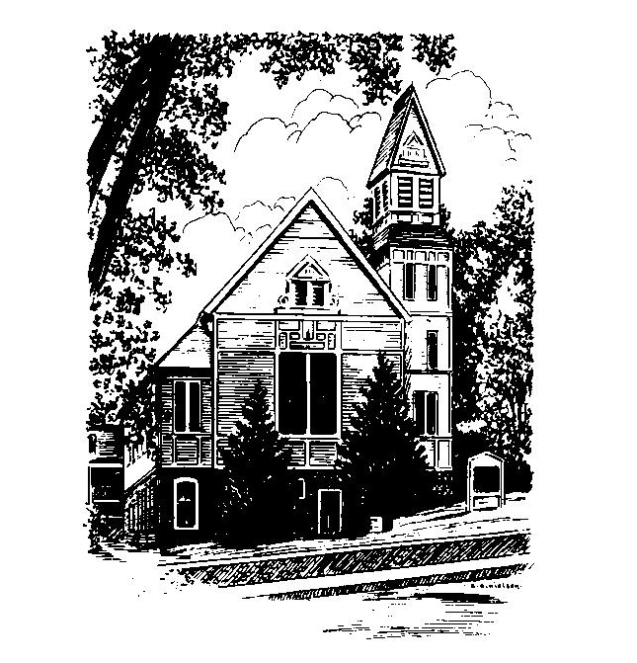
MEMORIAL CONGREGATIONAL CHURCH
U.C.C. BALDWINVILLE, MA.
An Open and Affirming Church of
the United Church of Christ
April 23, 2023
Third Sunday of Easter
No Matter Who You Are, No Matter Where You Are on Life’s
Journey; You Are Welcome Here!
PRELUDE:
WELCOME:
CALL TO WORSHIP
One We gather in this holy season celebrating the mystery of
Christ’s Resurrection!
ALL: We gather with songs of praise and prayers of hope!
One: God calls us into sacred service, living towards God’s
Kingdom of love and justice.
ALL: We pray for God’s guidance and God’s wisdom in our
living as we give thanks for the grace that sustains us.
One: The power of God’s love is here to renew us as we
celebrate together!
*OPENING HYMN: I Sing the Mighty Power of God
Black hymnal 12
OPENING PRAYER: (unison) O God of Easter’s Resurrection, again we come to this sanctuary seeking to be in tune with your spirit and to strengthen the church you have called into being. Amidst the lingering shadows of doubt and denial in our time we would find faith and hope echoed in the prayers and hymns of worship. Surprise us again with your Easter joy. Let this service stir us to deeper fidelity and a clearer connection to your redeeming work in the world. Help us as we unite in celebrating your promises to let your presence undergird our lives. Amen
*SHARING THE PEACE OF CHRIST
One: May the peace of Christ be with you!
Many: And also with you!
--Please “Pass the Peace” however you feel comfortable as we
sing Amen!
*AMEN (Sung twice) Red Hymnal #317
Amen, Amen, Amen, Amen, Amen
OFFERING OURSELVES AND OUR GIFTS TO GOD: --Our offering will be brought forward as we sing: ( If you have not put you offering in the offering plate you may do so now)
Praise God, from whom all blessings flow;
Praise God, all creatures here below;
Alleluia! Alleluia!
Praise God above, you heavenly host;
Praise Father, Son, and Holy Ghost.
Alleluia! Alleluia! Alleluia!
Alleluia! Alleluia!
The tune with different words may be found in the Red Hymnal #22
*DEDICATION: Again O’ God we bring something of our substance as well as our prayers as we gather in worship. Use this church, we pray, and all that we are, that we might be an instrument of your healing in our world. Let us be a light of love and service in this community as a people whose heart rests in you. Amen.

FIRST SCRIPTURE: 1 Peter 1: 17 -23
SPECIAL MUSIC:
SECOND SCRIPTURE: Luke 24: 13 -35
SERMON: Recognizing Christ
HYMN: Come Thou Fount of every Blessing
Black Hymnal # 459
SHARING OUR PRAYERS, OUR JOYS, OUR HOPES --PASTORAL PRAYER
THE LORD’S PRAYER : Our father who art in heaven hallowed be thy name. Thy kingdom come thy will be done on earth as it is in heaven. Give us this day our daily bread and forgive us our trespasses as we forgive those who trespass against us. And lead us not into temptation but deliver us from evil. For thine is the kingdom and the power and the glory forever. Amen.
-Response (sung)
Hear our Prayer, O Lord, Hear our prayer O Lord.
Incline thine ear to us, and grant us thy peace. Amen

*HYMN: We Would Be Building Black Hymnal # 607
*SENDING FORTH:
One: With thankful hearts for all God’s blessings go forth to live
in faith.
ALL: Rejoicing in God’s goodness and care, we seek the
Spirit’s guidance to live the redemptive purposes of
God. May God strengthen us in all our endeavors.
Amen and Amen

POSTLUDE

