To Contact Us:

Church Office: 978-939-8821
Church website: www.baldwinvillecongochurch.org
Minister: Rev. Richard A. Jones -413-283- 4440
E-mail Revraj@aol.com
Organist: Michelle Salvanelli
Vidiographer: Jeff Salvanelli
Church WiFi password: Memorial 1874

Deacon of the Month: Lei Messer
Reader Today: Lei Messer

ANNOUNCEMENTS
Today: Confirmation after church
COMMUNION TODAY
We take communion by intinction. We invite all who would share in Christ’s grace to come forward and take bread and dip it in the communion cup and eat with the blessing of God.

Next Sunday: Deacons and Trustees after Church-

Meditation Thought
"Place your mind before the mirror of eternity! Place your soul in the brilliance of glory! Place your heart in the figure of the divine substance! And transform your whole being into the image of the Godhead itself through contemplation!"
Clare of Assisi

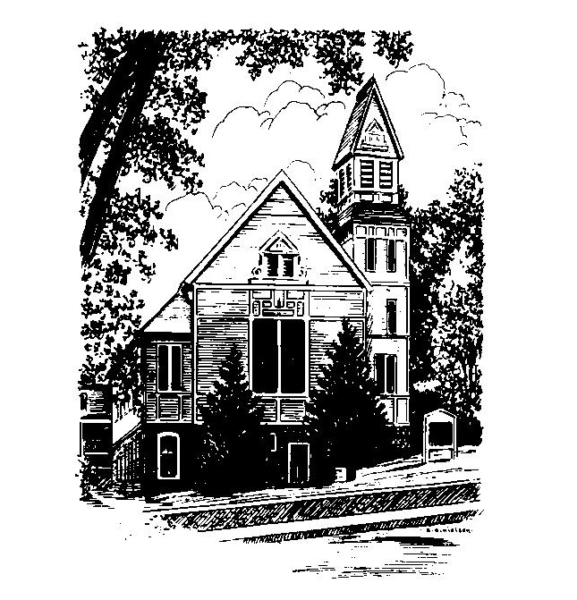
MEMORIAL CONGREGATIONAL
CHURCH U.C.C.
Baldwinville
An Open and Affirming Church of the United Church of Christ
January 1, 2023 10:00 AM
No Matter Who You Are, No Matter Where You
Are on Life’s Journey, You Are Welcome Here!
PRELUDE:
WELCOME
CALL TO WORSHIP
One: The calendar has turned, a new year has begun; come
give praise to God for the days that run before you!
ALL: We join in praise as our lives move forward in the
sweep of time. Thanks be to God for the gift of life, and
hope, and possibilities not yet dreamed of.
One: For the God of grace, time is but a moment and eternity
the mystery of tomorrow.
ALL: Embraced by God’s Eternal Love we seek to celebrate
God’s gifts and use our lives in loving thanks.
*OPENING HYMN: Brightest and Best Red Hymnal #174
OPENING PRAYER: (unison) Holy God, as we prepare to share in the supper Jesus gave us in this new year, we ask that your grace might come to us. We think of his commitment, even unto death, and we are reminded of the feebleness of our own faith. Open us to his holy presence and help us to drink more deeply of his spirit. Stir us to lives more committed to the Way he showed and more deeply rooted in the forgiveness you have offered in him. Teach us how we may bring forth the best of what it means to be followers of Jesus and sustain the heritage of faith we have been given. Amen.
*SHARING THE PEACE OF CHRIST
One: May the peace of Christ be with you!
Many: And also with you!

*AMEN (Sung twice): Red Hymnal #317
OFFERING OURSELVES AND OUR GIFTS TO GOD:
As you bring your offering let us sing together:
Praise God, from whom all blessings flow;
Praise God, all creatures here below;
Alleluia! Alleluia!
Praise God above, you heavenly host;
Praise Father, Son, and Holy Ghost.
Alleluia! Alleluia! Alleluia!
Alleluia! Alleluia!
*DEDICATION: Holy God, as this year begins to unfold
we come before you with our thanks and our commitment,
asking that your spirit might guide us and use us in our
work together and in our lives. Let your blessing enhance
the offerings we bring to strengthen the ministry of Christ’s
church in the world. Amen.

FIRST SCRIPTURE: Psalm 148
SPECIAL MUSIC
SECOND SCRIPTURE: Matthew 2 :13 -23
SERMON MEDITATION: Matthew’s Magi
*COMMUNION HYMN: Lord of Our Highest Love
Red hymnal # 390

SHARING OUR PRAYERS, OUR JOYS, OUR HOPES

--PASTORAL PRAYER
THE LORD’S PRAYER –Our father who art in heaven hallowed be thy name. Thy kingdom come thy will be done on earth as it is in heaven. Give us this day our daily bread and forgive us our trespasses as we forgive those who trespass against us. And lead us not into temptation but deliver us from evil. For thine is the kingdom and the power and the glory forever. Amen.
-Response (sung)
Hear our Prayer, O Lord, Hear our prayer O Lord.
Incline thine ear to us and grant us thy peace.
INVITATION TO THE TABLE
Everyone, of all ages, who seeks God’s presence is welcome at this table!.
WORDS OF INSTITUTION -Minister
DECLARATION:
Minister: And so, remembering what Christ has done for us, we
come to this table in thanksgiving and commitment, affirming
the ancient creed of our faith:
ALL:(Sung) Christ has died. Christ has Risen. Christ will
come again.

SHARING THE BREAD AND CUP
*HYMN: As With Gladness Red hymnal #173
*SENDING FORTH:
One: May God inspire your dreams and bless your days with the mystery of Christ’s presence through the new year
ALL: The carols of Christmas ring in our ears and the joy of our faith gives strength to our lives. We rejoice with hope as we affirm “God with us!” Amen.

POSTLUDE:

