To Contact Us:
Church Office: 978-939-8821
Church website: www.baldwinvillecongochurch.org
Rev. Richard A. Jones -413-283-4440
Revraj@aol.com
Organist: Michelle Salvanelli
Videographer: Jeff Salvanelli
Church wi-fi password: Memorial 1874

Deacon of the Month: Lei Messer
Liturgist: Lei Messer
Today: ANNUAL MEETING immediately after church
Coffee and conversation downstairs after the meeting
Next Sunday: Confirmation after Church
We are now colleting canned goods & food for the Food Pantry
*denotes “All who are able please stand”.
Masking is optional for worship.
Meditation Thought
Macrina Wiederkehhr, a Benedictine sister and spiritual writer has said, “I have seen too many stars to let the darkness overwhelm me.” And she adds, “We know there are stars so far away that their light has not yet reached earth. Could the same be said about some of the bright ideas, virtues, creativity, dreams, and changes that we need and long to see at work in the world?”

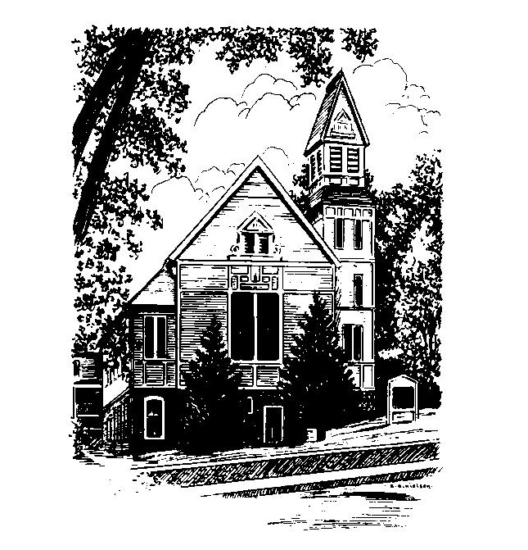
MEMORIAL CONGREGATIONAL CHURCH U.C.C. BALDWINVILLE, MA.
An Open and Affirming Church of
the United Church of Christ
January 29, 2023
Fourth Sunday after Epiphany
No Matter Who You Are, No Matter Where
You Are on Life’s Journey; You Are Welcome Here!
PRELUDE:
WELCOME:
CALL TO WORSHIP
One: Winter’s cold numbs the flesh but the Spirit of God warms
the Soul.
ALL: We come seeking the fire of God’s Spirit infusing us
with hope and calling us to service.
One: We are called to live in love, a community of the faithful,
living out God’s grace.
ALL: We come seeking God’s purpose in our lives; we
come with our failures and our hopes, our dreams and
our fears.
One: Gather to sing praise! Let your song be heard. Let your
voices unite in joy and wonder .
ALL: From our many homes and families we join in a
common song of praise, a song of hope, a song of
grace.

*OPENING HYMN: God Reigns O’er All the Earth
Black hymnal # 21
OPENING PRAYER: (unison) O’ God of yesterday and tomorrow we come to you with hope in our hearts; hope for our families; hope for a better world; hope for our church; hope for your love to be the transforming force that nurtures new beginnings. Make us open to your Spirit and the grace you are ready to impart. When we feel despair, lift us up. When we lose sight of our goals or our direction, reorient us. When our dreams are shattered help us feel your healing grace and hold us in the depth of your love. We ask it in Jesus’ name. Amen.
*SHARING THE PEACE OF CHRIST
One: May the peace of Christ be with you!
Many: And also with you!
--Please “Pass the Peace” however you feel comfortable as we
sing Amen!
*AMEN (Sung twice) Red Hymnal #317
Amen, Amen, Amen, Amen, Amen
OFFERING OURSELVES AND OUR GIFTS TO GOD: --Our offering will be brought forward as we sing: ( If you have not put you offering in the offering plate you may do so now)
Praise God, from whom all blessings flow;
Praise God, all creatures here below;
Alleluia! Alleluia!
Praise God above, you heavenly host;
Praise Father, Son, and Holy Ghost.
Alleluia! Alleluia! Alleluia!
Alleluia! Alleluia!
The tune with different words may be found in the Red Hymnal #22
*DEDICATION: In commitment together and in thankfulness of heart, O God, we bring our offerings today. Let your spirit permeate all we do here; inspire our vision and strengthen our covenant together. We dedicate all we give to the redeeming work of Jesus in our world. Amen.

FIRST SCRIPTURE: Micah 6: 1 -8
SPECIAL MUSIC:
SECOND SCRIPTURE: Matthew 5: 1 -12
SERMON: Blessed Beatitudes
HYMN: Won’t You Let Me Be Your Servant
Black Hymnal #354
SHARING OUR PRAYERS, OUR JOYS, OUR HOPES --PASTORAL PRAYER
THE LORD’S PRAYER : Our father who art in heaven hallowed be thy name. Thy kingdom come thy will be done on earth as it is in heaven. Give us this day our daily bread and forgive us our trespasses as we forgive those who trespass against us. And lead us not into temptation but deliver us from evil. For thine is the kingdom and the power and the glory forever. Amen.
-Response (sung)
Hear our Prayer, O Lord, Hear our prayer O Lord.
Incline thine ear to us, and grant us thy peace. Amen

*HYMN: Called as Partners Black+ Hymnal # 495

*SENDING FORTH:
One: You are the Body of Christ in the world. Go from this
place renewed in grace and committed to live out God’s
love.
ALL: We leave this house of worship strengthened by the
love of God and renewed in our intentions to live
faithfully and walk humbly with our God.

POSTLUDE

