To Contact Us:
Church Office: 978-939-8821
Church website: www.baldwinvillecongochurch.org
Rev. Richard A. Jones -413-283-4440
Revraj@aol.com
Organist: Michelle Salvanelli
Videographer: Jeff Salvanelli
Church wi-fi password: Memorial 1874

Deacon of the Month: Lei Messer
Liturgist: Noel Francis
Today: Coffee and conversation downstairs after church
Next Sunday: ANNUAL MEETING immediately after church.
We are now colleting canned goods & food for the Food Pantry
*denotes “All who are able please stand”.
Masking is optional for worship.
Meditation Thought
“Sometimes I feel quite distinctly that what is inside me is not all of me. There is something else, sublime, quite indestructible, some tiny fragment of the Universal spirit”. -Aleksandr Solzhenitsyn

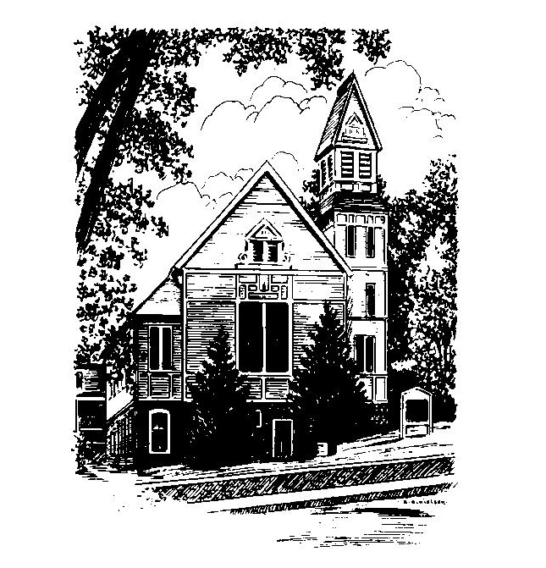
MEMORIAL CONGREGATIONAL CHURCH U.C.C. BALDWINVILLE, MA.
An Open and Affirming Church of
the United Church of Christ
January 22, 2023
Third Sunday after Epiphany
No Matter Who You Are, No Matter Where
You Are on Life’s Journey; You Are Welcome Here!
PRELUDE:
WELCOME:
CALL TO WORSHIP
One: This new year, blessed with hope, but stressed with fears,
lies before us with all its possibilities.
ALL God is with us; we rejoice in the hope and find
strength amidst our anxieties for the future.
One: God has called us to the challenges of our times and
promises the Spirit will be with us in good times and bad.
ALL: We rejoice in God’s grace and seek to live with new
conviction for justice and caring in our world.
One: Thanks be to God!

*OPENING HYMN: Great Is Thy Faithfulness
Red hymnal # 86
OPENING PRAYER: (unison) Holy God, we gather again in awe knowing that you are beyond all our definitions. You are creator and sustainer of the universe and the source of grace in our lives. The hush of grief is around us for the pain of our world, but so too, the power of your hope and your love. Come, be among us Holy One, and let your Eternal Presence strengthen us anew. Ennoble us to the tasks of our time and bind us to you and to one another as we share in this journey of faith together. Amen

*SHARING THE PEACE OF CHRIST
One: May the peace of Christ be with you!
Many: And also with you!
--Please “Pass the Peace” however you feel comfortable as we
sing Amen!
*AMEN (Sung twice) Red Hymnal #317
Amen, Amen, Amen, Amen, Amen
OFFERING OURSELVES AND OUR GIFTS TO GOD: --Our offering will be brought forward as we sing: ( If you have not put you offering in the offering plate you may do so now)
Praise God, from whom all blessings flow;
Praise God, all creatures here below;
Alleluia! Alleluia!
Praise God above, you heavenly host;
Praise Father, Son, and Holy Ghost.
Alleluia! Alleluia! Alleluia!
Alleluia! Alleluia!
The tune with different words may be found in the Red Hymnal #22
*DEDICATION: O God we give thanks for the mystery and wonder of life and for all the myriad ways we experience your grace in our lives. We dedicate anew these offerings to your purposes in the world. Let them truly serve your redeeming hope. Amen.
FIRST SCRIPTURE: I Corinthians 1:10 - 18
SPECIAL MUSIC:
SECOND SCRIPTURE: Matthew 4: 12 -23
SERMON: United in Call
HYMN: Seek Ye First Red Hymnal #354
SHARING OUR PRAYERS, OUR JOYS, OUR HOPES --PASTORAL PRAYER
THE LORD’S PRAYER : Our father who art in heaven hallowed be thy name. Thy kingdom come thy will be done on earth as it is in heaven. Give us this day our daily bread and forgive us our trespasses as we forgive those who trespass against us. And lead us not into temptation but deliver us from evil. For thine is the kingdom and the power and the glory forever. Amen.
-Response (sung)
Hear our Prayer, O Lord, Hear our prayer O Lord.
Incline thine ear to us, and grant us thy peace. Amen

*HYMN: Standing on the Promises Red Hymnal # 552

*SENDING FORTH:
One: Let the light of Christ shine in your hearts and in your
lives.
All: We would continue to open ourselves to Christ’s light;
may God’s Spirit continue to guide our journey and
strengthen us for the tasks ahead.
One May God’s Holy Spirit give you peace and fill you with the
assurance of God’s love.
ALL Amen and Amen.

POSTLUDE

