To Contact Us:
Church Office: 978-939-8821
Church website: www.baldwinvillecongochurch.org
Rev. Richard A. Jones -413-283-4440
Revraj@aol.com
Organist: Michelle Salvanelli
Videographer: Jeff Salvanelli
Church wi-fi password: Memorial 1874

Deacon of the Month: Lei Messer. Liturgist: Joanne Francis
Today: Coffee and conversation downstairs after church
We are now colleting canned goods & food for the Food Pantry
*All who are able please stand. Masking is optional for worship.
Rev. Jones is away today. Mike Scott is leading worship.
Meditation Thought
“We are in constant danger of being not actors in the drama of our own lives but reactors. The fragmentary nature of our experience shatters us into fragments. Instead of being whole, most of the time we are in pieces, and we see the world in pieces, full of darkness at one moment and full of light the next.
It is in Jesus, of course, and in the people whose lives have been deeply touched by Jesus, and in ourselves at those moments when we also are deeply touched by him, that we see another way of being human in this world, which is the way of wholeness. When we glimpse that wholeness in others, we recognize it immediately for what it is, and the reason we recognize it, I believe, is that no matter how much the world shatters us to pieces, we carry inside us a vision of wholeness that we sense is our true home and that beckons to us.”
― Frederick Buechner, from The Longing for Home
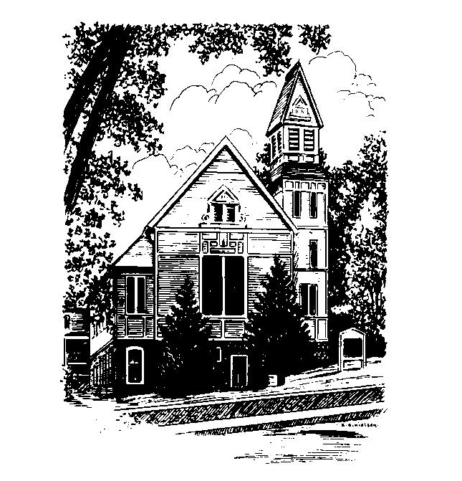
MEMORIAL CONGREGATIONAL CHURCH U.C.C. BALDWINVILLE, MA.
An Open and Affirming Church of
the United Church of Christ
January 15, 2023
Second Sunday after Epiphany
No Matter Who You Are, No Matter Where
You Are on Life’s Journey, You Are Welcome Here!

PRELUDE
WELCOME
CALL TO WORSHIP (From Psalm 96)

Leader: Sing to the LORD, all the earth.
People: Sing to the LORD, bless His name;
proclaim His salvation day after day.
Leader: Declare His glory among the nations,
People: His wonderful deeds among all peoples.

*OPENING HYMN Mine Eyes Have Seen the Glory
Red Hymnal # 705

OPENING PRAYER (unison) O Spirit of Life and Love, who has made all races to dwell upon the earth as one family, break down the barriers of fear and suspicion that divide us, we pray. Build bridges of love and justice which lead us to greet one another as brothers and sisters, and to embrace one another in reconciling fellowship. Gathering us hand to hand, lead us to join with you to make justice in the land and to make life a blessing for all, that in everything your name would be praised. Amen.

*SHARING THE PEACE OF CHRIST
One: May the peace of Christ be with you!
Many: And also with you!
--Please “Pass the Peace” however you feel comfortable

*AMEN (Sung twice) Red Hymnal #317
Amen, Amen, Amen, Amen, Amen

MORNING OFFERING --Our offering will be brought forward as we sing: (If you have not put you offering in the offering plate you may do so now)
Praise God, from whom all blessings flow;
Praise God, all creatures here below;
Alleluia! Alleluia!
Praise God above, you heavenly host;
Praise Father, Son, and Holy Ghost.
Alleluia! Alleluia! Alleluia!
Alleluia! Alleluia!
The tune with different words may be found in the Red Hymnal #22

PRAYER OF DEDICATION

SCRIPTURE READINGS Isaiah 49:1-7
John 1:29-42

SPECIAL MUSIC

SERMON What’s In a Name?

HYMN Precious Lord, Take My Hand Red Hymnal # 628

SHARING OUR PRAYERS, OUR JOYS, OUR HOPES
PASTORAL PRAYER
THE LORD’S PRAYER
Our father who art in heaven hallowed be thy name. Thy kingdom come thy will be done on earth as it is in heaven. Give us this day our daily bread and forgive us our trespasses as we forgive those who trespass against us. And lead us not into temptation but deliver us from evil. For thine is the kingdom and the power and the glory forever. Amen.
-Response (sung)
Hear our Prayer, O Lord, Hear our prayer O Lord.
Incline thine ear to us, and grant us thy peace. Amen

*HYMN We Shall Overcome Red Hymnal # 630

*BENEDICTION

POSTLUDE

