To Contact Us:
Church Office: 978-939-8821
Church website: www.baldwinvillecongochurch.org
Rev. Richard A. Jones -413-283-4440
Revraj@aol.com
Organist: Michelle Salvanelli
Videographer: Jeff Salvanelli
Church wi-fi password: Memorial 1874

Deacon of the Month: Lei Messer
Liturgist: Lei Messe
Today: Coffee and conversation downstairs after church
Deacons & Trustees will meet today.
We are now colleting canned goods & food for the Food Pantry
*denotes “All who are able please stand”.
Masking is optional for worship.
Meditation Thought
“Love of one’s fellowmen should not be a doctrine, an article of faith, a matter of intellectual conviction, or a thesis supported by arguments. The love of mankind which requires reasons is no true love. This love should be perfectly natural, as natural for man as for the birds to flap their wings. It should be a direct feeling, springing naturally from a healthy soul, living in touch with Nature.”
― Lin Yutang, Lin Yutang: The Importance Of Living

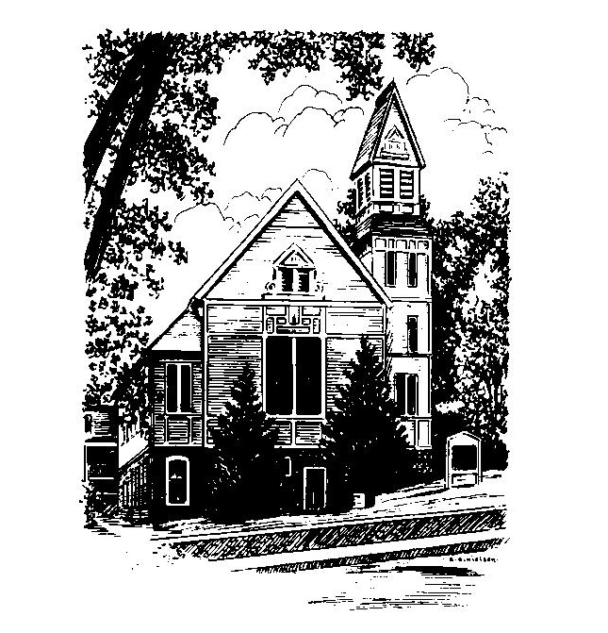
MEMORIAL CONGREGATIONAL CHURCH U.C.C. BALDWINVILLE, MA.
An Open and Affirming Church of
the United Church of Christ
January 8, 2023
First Sunday after Epiphany
No Matter Who You Are, No Matter Where
You Are on Life’s Journey, You Are Welcome Here!
PRELUDE:
WELCOME:
CALL TO WORSHIP:
One: The New Year has come and stands before us with
all its possibilities and surprises.
ALL: We come to this sacred space giving thanks for the
gift of life and trusting in God’s grace to sustain us
through all the unknowns that may come.
One: God’s Spirit is the breath of life and the creative
urging for a redemptive future. God’s love is without end!
ALL: In God we live and move and have our being! Thanks
be to God!
*OPENING HYMN: All People that on Earth do Dwell
Black hymnal # 7
OPENING PRAYER: (unison) O timeless Lord of all our days and years, now in the opening days of this new year we remember and reflect: provide us with your Spirit as companion as we seek to follow Jesus. Put from us, in the mercy of your grace, the waste of hours, the dry seasons, the desolate evenings, and the shabby dawns. Go with us into the mystery of the days that run so quickly before us. Show us the everlasting in the perishable, the hope in defeat, the purpose in chaos. Help us arise to each morning, glad that its seconds have the height of your eternity; through Jesus Christ our Lord. Amen. (adapted from Arnold Kenseth)
*SHARING THE PEACE OF CHRIST
One: May the peace of Christ be with you!
Many: And also with you!
--Please “Pass the Peace” however you feel comfortable as we
sing Amen!
*AMEN (Sung twice) Red Hymnal #317
Amen, Amen, Amen, Amen, Amen
OFFERING OURSELVES AND OUR GIFTS TO GOD: --Our offering will be brought forward as we sing: ( If you have not put you offering in the offering plate you may do so now)
Praise God, from whom all blessings flow;
Praise God, all creatures here below;
Alleluia! Alleluia!
Praise God above, you heavenly host;
Praise Father, Son, and Holy Ghost.
Alleluia! Alleluia! Alleluia!
Alleluia! Alleluia!
The tune with different words may be found in the Red Hymnal #22
*DEDICATION: O You who are the Beginning and the End we come together today giving thanks and committing ourselves to work for the justice and caring in the world that you urge us to create. Bless our work together and these offerings that we might truly make a difference in our little corner of the world. Amen.

FIRST SCRIPTURE: Isaiah 42: 1 – 9
SPECIAL MUSIC:
SECOND SCRIPTURE: Matthew 3: 13 - 17
SERMON: Baptized and Called
HYMN: Not My Brother, Not My Sister- Black Hymnal # 519
SHARING OUR PRAYERS, OUR JOYS, OUR HOPES --PASTORAL PRAYER
THE LORD’S PRAYER : Our father who art in heaven hallowed be thy name. Thy kingdom come thy will be done on earth as it is in heaven. Give us this day our daily bread and forgive us our trespasses as we forgive those who trespass against us. And lead us not into temptation but deliver us from evil. For thine is the kingdom and the power and the glory forever. Amen.
-Response (sung)
Hear our Prayer, O Lord, Hear our prayer O Lord.
Incline thine ear to us, and grant us thy peace. Amen

*HYMN: You Have Come Down to the Lakeshore
Black Hymnal # 173

*SENDING FORTH:
One: May the Light of Christ lead you in the journey of your
lives.
ALL: We seek to follow Jesus and to let his love fill our
hearts.
One: May God bless you and keep you in his grace, now and
always.
ALL: Amen.

POSTLUDE

