JOY
Today we light the Advent candle of Joy.

Joy is the rich inner feeling when life becomes a sacred gift; when all the future radiates with possibility and the present is expanded with the sheer wonder of life.

Joy is a mood and a feeling but it is also an affirmation of faith and the incarnation of hope. In joy the human spirit swells with the vibrancy and richness of humanity at its best! In joy one may be united with the mystery and magnitude of creation and creator.
Joy was the wondrous feeling of all those who saw in the manger that night a gift of God and the hope of the ages fulfilled.
Joy is expressed in all the heart- warming carols that speak so poetically of God in a manger, God with us in the here-and-now of our desperate world; God coming to save and redeem in the vulgar realities of a stable.
The wonder of Christmas is always expressed in the spontaneous, irrepressible joy at the miracle of the infant’s birth and God’s redeeming Grace born among us.
Today we reaffirm the deep joy of all those who gathered at the manger that night. It is the joy inherent in the miracle of Christmas.
Today we light the Advent Candle of JOY.

MEMORIAL
CONGREGATIONAL
CHURCH
U.C.C.
Baldwinville, Mass.

An Open and Affirming Church of
the United Church of Christ
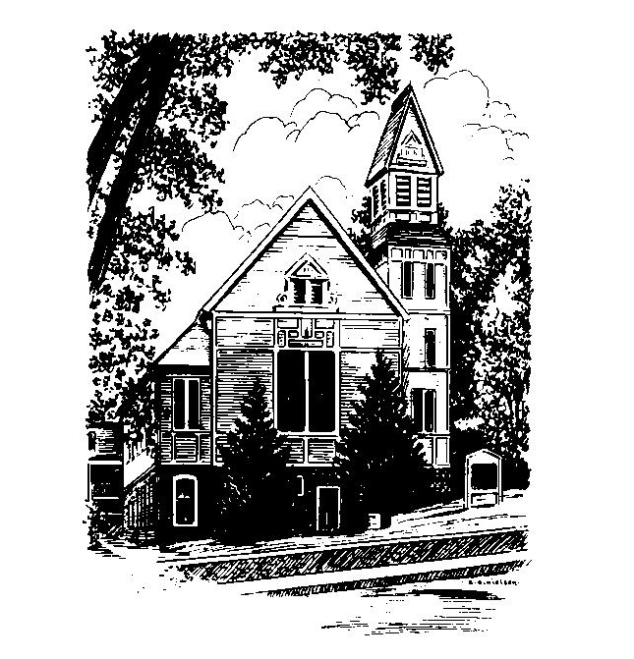
December 11. 2022
Third Sunday of Advent

No Matter Who You Are,
No Matter Where You Are on Life’s Journey,
You Are Welcome Here!

WELCOME
Welcome to our first-time guests!
Welcome to those who have no church home, need strength, have doubt, want to follow Christ, or even do not believe. Welcome to those who have more questions than answers or aren't sure where they are on their journey of faith!
Welcome to those who were baptized here and have worshiped in this place for generations!
Welcome to people of all sexual orientations & gender identities, to people of all racial & ethnic heritages, and to families of every shape and size!
May God find you where you are
and welcome you home

PRELUDE:
(Please remember some will be in meditative silence during the prelude)

WELCOME & ANNOUNCEMENTS

CALL TO WORSHIP
One: The God of Advent waits; waits for hearts to open,
faith to bloom and hope to take root.
ALL: We come seeking to connect to God’s grace, to
unlock the way for God’s miracle to be born in us.
One: Let our carols be raised and our prayers ascend with
hearts knowing that God comes to us!
ALL: We make ready for the holy that would touch our
lives. In anticipation, we wait for a transforming
love that would nourish human hearts to deeds of
mercy and grace.

Meditation Thought
Christmas is Waiting to be Born
Where refugees seek deliverance that never comes;
And the heart consumes itself as if it would live; Where children age before their time; And life wears down the edges of the mind, Where the old man sits with mind grown cold while bones and sinew, blood and cell, go slowly down to death, Where fear companions each day's life, And Perfect Love seems long delayed. Christmas is waiting to be born: In you, in me, in all mankind.
--Howard Thurman

Please join us for coffee hour downstairs immediately after worship.

To Contact Us:
Church Office: 978-939-8821
Web Site: www.baldwinvillecongochurch.com
The Rev. Richard A. Jones, Minister
E-mail: Revraj@aol.com
Tel: 413- 283- 4440
Organist: Michelle Salvanelli
978-632-4901

Deacon for December: Joanne Francis

Liturgist: Sandy Skinner

Calendar of Upcoming Events:

Today: Deacons after Church
Wed. 6:00: Ames-More Guild
Christmas Sunday (Dec. 18): Bring bells to ring
Christmas Eve Service of Carols and Candles 5:00 PM

*OPENING HYMN: Hail to the Lord’s Anointed
Black Hymnal #104
Opening Prayer: O God, of Advent’s longing, come move among us, we pray, and help our limping imaginations wonder at the way your grace has moved in our lives and your presence has been born into our world. We seek to touch something of your mystery in this time together: stir us, renew us, heal us, and transform us to live truer lives in your love. Inspire us again, Incarnate God, through the Spirit that was in Jesus, that we too might stir the world with our faith and faithfulness. In Christ’s name, amen.

*SHARING THE PEACE OF CHRIST
One: May the peace of Christ be with you!
Many: And also with you!

*AMEN (Sung twice): Red Hymnal #317
Amen, Amen,
Amen, Amen, Amen.

LIGHTING OF THE ADVENT CANDLE
(words on back of bulletin) Jim and Linda Bevan

CORAL RESPONSE: Light One Candle

OFFERING OURSELVES AND OUR GIFTS TO GOD:
“Lord Jesus Christ, today I offer my life to you.
Create a miracle in my life and in our church.”

You are invited to bring forward your offering while we sing together: +

Praise God, from whom all blessings flow;
Praise God, all creatures here below;
Alleluia! Alleluia!
Praise God above, you heavenly host;
Praise Father, Son, and Holy Ghost.
Alleluia! Alleluia! Alleluia!
Alleluia! Alleluia!
The tune with different words may be found in the Red Hymnal #22

*DEDICATION OF OUR OFFERING
O God of Manger and Cross who has given us more than we can name, we bring our offerings for the work of your church with thankful hearts.. Use these offerings that represent our time and our energy that this church might truly lift up your love and hope in the world. Amen.

FIRST SCRIPTURE: Isaiah 35: 1 - 10

SPECIAL MUSIC

NEW TESTAMENT LESSON: Matthew 11: 2 -11

SERMON: John’s Haunting Question

HYMN: In the Bleak Midwinter
Black hymnal #128
SHARING OUR PRAYERS, OUR JOYS AND
SORROWS
PASTORAL PRAYER

THE LORD’S PRAYER
Our Father, who art in heaven, hallowed be thy name. Thy kingdom come. Thy will be done on earth as it is in heaven. Give us this day our daily bread. And forgive us our trespasses, as we forgive those who trespass against us. And lead us not into temptation, but deliver us from evil. For thine is the kingdom, and the power, and the glory, forever. Amen.
CHORAL PRAYER RESPONSE: #306 Red Hymnal
Hear our Prayer, O Lord, Hear our prayer O Lord.
Incline thine ear to us, and grant us thy peace.

*CLOSING HYMN: The first Nowell
Black hymnal #139

*SENDING FORTH:
One: May the God of guiding stars and the joyous sounds
of angel songs be present to you and bless you in the
journey of your lives.
All: May God’s grace go with us and inspire our
longing hearts in the ways of Christ’s kingdom.
Amen.

POSTLUDE:

*All who are able please stand

