Meditation Thought
“In the silence of a midwinter dusk there is far off in the deeps of it somewhere a sound so faint that for all you can tell it may be only the sound of the silence itself. You hold your breath to listen…. For a second you catch a whiff in the air of some fragrance that reminds you of a place you've never been and a time you have no words for. You are aware of the beating of your heart…The extraordinary thing that is about to happen is matched only by the extraordinary moment just before it happens. Advent is the name of that moment.” -Fred. Buechner

MEMORIAL
CONGREGATIONAL
CHURCH
U.C.C.
Baldwinville, Mass.

An Open and Affirming Church of
the United Church of Christ
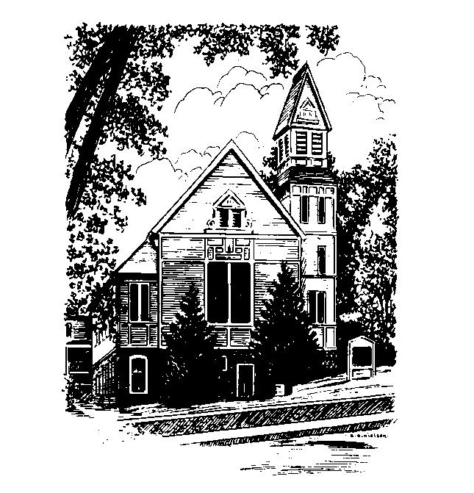

December 4, 2022
Second Sunday of Advent

No Matter Who You Are,
No Matter Where You Are on Life’s Journey,
You Are Welcome Here!

WELCOME
Welcome to our first-time guests!
Welcome to those who have no church home, need strength, have doubt, want to follow Christ, or even do not believe. Welcome to those who have more questions than answers or aren't sure where they are on their journey of faith!
Welcome to those who were baptized here and have worshiped in this place for generations!
Welcome to people of all sexual orientations & gender identities, to people of all racial & ethnic heritages, and to families of every shape and size!
May God find you where you are
and welcome you home

PRELUDE:
(Please note that some use this time for silent meditation)

WELCOME AND ANNOUNCEMENTS

CALL TO WORSHIP
One: It is the season of faith where hope is renewed and joy
and peace fill our hearts.
ALL: We wait in faith, longing for a new birth of God’s
grace in our world.
One: Faith moves us to live towards the vision of God’s love
and sing of miracle and grace in our broken world.
ALL: We pray for God’s Love, so evident in the Babe of
Bethlehem and the Christ of the cross, to be more
alive in us that we might be more alive with God’s
Spirit.

THE ADVENT CANDLE OF PEACE

Today we light the Advent Candle of Peace.
Peace is the longing of the ages. People in every time and place have sought its promise.
Peace is always the vision of prophets. Where true love
of God is, peace must follow.
Peace is not a momentary interlude but the fulfillment of
faith and faithfulness.
Peace is a state of mind when life feels secure and hope is
undaunted by fear.
Peace gives birth to dreams and liberates potentialities
that once seemed only illusions.
Peace gives food to the hungry and drink to the thirsty.
Peace is the mother of tomorrow and gives hope to our
children’s children. True peace is a herald of God’s
Reign.
Peace is symbolized in the sleeping Babe of Bethlehem,
quietly, trustfully resting, undeterred by the crosses and
clamoring’s that sometimes pervade the world.
Peace is evident in the shepherds watching their flocks
on a silent starlit night.
Peace is witnessed to by an angel chorus singing.
“Peace on earth goodwill to mankind”
Peace is affirmed by Wise Men bringing gifts from afar.
Peace is that place where fears and threats are laid
to rest and hate finds no place to grow.
Today we light the Advent Candle of Peace.
May the peace of God abide with each of us.

To Contact Us:
Church Office: 978-939-8821
Church website: www.mccbaldwinville.com
Church e-mail: pastor@mccbaldwinville.com
Organist Michelle Salvanelli
978-632-4901
The Rev. Richard A. Jones, Minister
Tel: 413- 283- 4440
Revraj@aol.com

Deacon for December: Joanne Francis

Liturgist: Nowell Francis

Calendar of Upcoming Events:

Today is the last Sunday to order poinsettias -envelopes in the back
Wed. Dec. 14: Ames-More Guild -6:00pm at Old Mill Restaurant
Sun. Dec. 18 -Christmas Sunday bring a bell to ring!
Fri. Dec. 24 -Christmas Eve service 5:00 PM Lessons and Carols

OPENING PRAYER: (unison)
Gracious God who came to us humble and in a manger, we come to this place confessing that we have not always been as Shepherds opening our ears to hear an angle chorus, nor have we come to you as Wise Men, with ardent seeking. Sometimes we have only wanted you to serve us. Forgive us Lord where our faith becomes self-centered and out of focus. Help us to be renewed by your grace and strengthened to rediscover our calling; open our eyes to see the gifts you have already given and open our hearts that we might joyfully come to the manger of your presence. Amen.
*OPENING HYMN: Come O Long Expected Jesus
Black hymnal #122
LIGHTING OF THE ADVENT CANDLE
Deb Hubbard, Cher Flis & Carolee Eaton

CHORAL RESPONSE -Light One Candle

*SHARING THE PEACE OF CHRIST
One: May the peace of Christ be with you!
Many: And also with you!

*AMEN (Sung twice): Red Hymnal #317
Amen, Amen,
Amen, Amen, Amen.

OFFERING OURSELVES AND OUR GIFTS TO GOD:
You are invited to bring forward your offering while we sing together:
Praise God, from whom all blessings flow;
Praise God, all creatures here below;
Alleluia! Alleluia!
Praise God above, you heavenly host;
Praise Father, Son, and Holy Ghost.
Alleluia! Alleluia! Alleluia!
Alleluia! Alleluia!
The tune with different words may be found in the Red Hymnal #22
*DEDICATION: With hearts remembering the love you have shared with us in that one born in the manger of Bethlehem and then so callously put to death on a cross in Jerusalem, we come with our offerings and dedicate them to your service. Let our church be filled with your spirit and strengthened in our ministry. We ask in his name, amen.
OLD TESTAMENT READING: Isaiah 11: 1 - 10

SPECIAL MUSIC

GOSPEL LESSON: Matthew 3: 1 -12

COMMUNION MEDITATION:

COMMUNION HYMN: Be Known to Us in Breaking Bread
(Please remain seated) Black hymnal #342

SHARING OUR PRAYERS, OUR JOYS AND
SORROWS
PASTORIAL PRAYER

THE LORD’S PRAYER (said in unison)
Our Father, who art in heaven, hallowed be thy name. Thy kingdom come. Thy will be done on earth as it is in heaven. Give us this day our daily bread. And forgive us our trespasses as we forgive those who trespass against us. And lead us not into temptation, but deliver us from evil. For thine is the kingdom, and the power, and the glory, forever. Amen.

CHORAL PRAYER RESPONSE: #306 Red Hymnal
Hear our Prayer, O Lord, Hear our prayer O Lord.
Incline thine ear to us, and grant us thy peace.

INVITATION TO THE TABLE
Everyone, of all ages, who seeks God’s presence is welcome at
this table! Our communion is by intinction. Please take the
bread when offered by the minister and dip it into the cup
offered by the deacons. The chalices marked with a ribbon
contain wine, and the unmarked contain grape juice.

WORDS OF INSTITUTION (minister)

ACCLAMATION (799 Black Hymnal)
Minister: Let us sing the ancient creed of our faith:
ALL: Christ has died. Christ is Risen. Christ will come again.

Minister: This is the cup of Salvation and the Body of Christ
People: Thanks be to God for the grace made manifest to us in
Christ Jesus.

RECEIVING THE SACRAMENTS

*CLOSING HYMN: O Come, O Come Immanuel
Black hymnal # 116
*SENDING FORTH:
One: May God’s peace abide in your hearts and lives
now and always.
ALL: We will seek to live in God’s peace and let that
peace live in us.
One: May God lead you to the manger where hope is
born and love is the heavenly chorus.
ALL: May God grant us eyes to see and hearts to
embrace the gifts God has offered. Amen.

POSTLUDE:

