To Contact Us:

Church Office: 978-939-8821
Church website: www.baldwinvillecongochurch.org
Minister: Rev. Richard A. Jones -413 -283 - 4440
E-mail Revraj@aol.com
Organist: Michelle Salvanelli
Vidiographer: Jeff Salvanelli
Church WiFi password: Memorial 1874

Deacon of the Month: Lei Messer
Reader Today: Lei Messer

ANNOUNCEMENTS
Today: Confirmation after church
COMMUNION TODAY
You may choose to use the individual cup and wafer, or you may come forward and take a piece of bread and either dip it in the communion chalice, or take it to your seat and drink from the individual chalice. Please open your chalice carefully.

Next Sunday: Deacons after Church-

Meditation Thought
“I am deeply convinced that God is present both in the lives of every person and also in the lives of entire nations.”
-Aleksandr Solzhenitsyn, the late Soviet dissident.

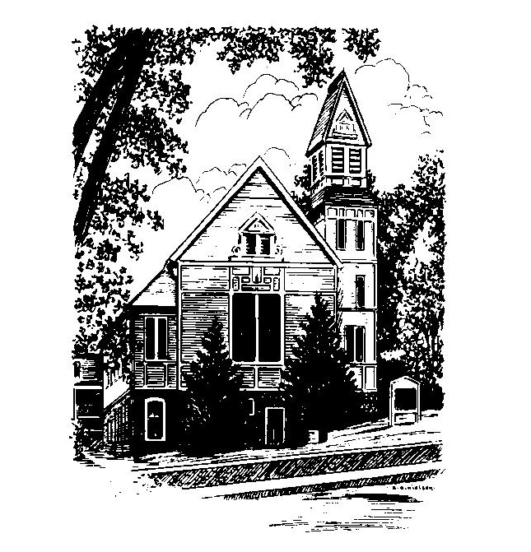
MEMORIAL CONGREGATIONAL
CHURCH U.C.C.
Baldwinville
An Open and Affirming Church of the United Church of Christ
November 6, 2022 10:00 AM
No Matter Who You Are, No Matter Where You
Are on Life’s Journey, You Are Welcome Here!
PRELUDE:
WELCOME
CALL TO WORSHIP
One: All who would receive the gifts of Grace come to this
place with open hearts, lay all malice aside and receive
God’s gifts.
ALL: We would receive the gifts Christ offered; we would
be fed by the Spirit.
One: All who are hungry and thirsty, come, eat and drink.
ALL: We thirst for the grace of God. We long for the Living
Water and the wine of the soul.
One: All you who hunger for the Spirit, come and eat, for Jesus
said, “I am the Bread of Life”.
ALL: Great God come, enliven us with your presence and
satisfy the longings of our hearts.

*OPENING HYMN: Creator God, Creating Still
Red Hymnal #62
OPENING PRAYER: (unison) Most gracious God, as we remember those who those who left their mark of faith and blessing on our lives, we pray that you would make us worthy and ready for the challenges of our times. Let your Christ come and be among us with his forgiveness and his call. Stir our hearts with a deeper understanding of your love and your hope. Remind us again of how you seek to bless and renew, redeem and make whole. Give us a new sense of purpose as you empower us to live the faith with the vision of the saints who have gone before. Amen
*SHARING THE PEACE OF CHRIST
One: May the peace of Christ be with you!
Many: And also with you!

*AMEN (Sung twice): Red Hymnal #317
OFFERING OURSELVES AND OUR GIFTS TO GOD:
As our deacon brings forward your offering let us sing together:
Praise God, from whom all blessings flow;
Praise God, all creatures here below;
Alleluia! Alleluia!
Praise God above, you heavenly host;
Praise Father, Son, and Holy Ghost.
Alleluia! Alleluia! Alleluia!
Alleluia! Alleluia!
*DEDICATION: God, the world is broken and we don’t know how to fix it but we would dedicate ourselves to live more rightly, more justly, more in tune with your hope for us. Use us then, and this offering we bring, that through it your church may witness to your grace and your truth. Amen.
FIRST SCRIPTURE: Psalm 145: 1-5 & 17 -21
SPECIAL MUSIC
SECOND SCRIPTURE: 2 Thessalonians 2: 1 -5 &13 -17
SERMON MEDITATION: Stray Cats & God
*COMMUNION HYMN: In Memory of the Savior’s Love
Red hymnal # 405
A TIME OF REMEMBERANCE:ALL SAINTS DAY (YOU ARE INVITED TO CALL OUT THE NAME OF SOMEONE
YOU WISH TO REMEMBER – THE CHURCH BELL WILL TOLL
AFTER EACH NAME)

SHARING OUR PRAYERS, OUR JOYS, OUR HOPES
THE LORD’S PRAYER –Our father who art in heaven hallowed be thy name. Thy kingdom come thy will be done on earth as it is in heaven. Give us this day our daily bread and forgive us our trespasses as we forgive those who trespass against us. And lead us not into temptation but deliver us from evil. For thine is the kingdom and the power and the glory forever. Amen.
-Response (sung)
Hear our Prayer, O Lord, Hear our prayer O Lord.
Incline thine ear to us and grant us thy peace.
INVITATION TO THE TABLE
Everyone, of all ages, who seeks God’s presence is welcome at this table!.
WORDS OF INSTITUTION -Minister
DECLARATION:
Minister: And so, remembering what Christ has done for us, we
come to this table in thanksgiving and commitment, affirming
the ancient creed of our faith:
ALL:(Sung) Christ has died. Christ has Risen. Christ will
come again.

SHARING THE BREAD AND CUP
*HYMN: Give Thanks for Life Black hymnal #649
*SENDING FORTH:
One: May that God who has given strength in ages past give
you strength and wisdom for living in these times.
ALL: We trust in God who has been the strength of
generations and is the hope for years to come. AMEN.

POSTLUDE:

