HOPE
Today we light the Advent Candle of Hope: Hope stands at the opening of Advent calling for us to embrace the gifts of God. Hope echoes through the centuries with prophetic voice: God is here! God still renews and redeems! The hope of the ages was born anew in the Christ Child, in shocked disciples cowering in an upper room, and in the heart of everyone who dares to live towards God’s vision.
Hope for a world touched by God; hope for our
lives renewed by God’s love.
Hope is the primary ingredient in Advent and
fundamental to the Christmas faith.
Hope has the will to hold sway over the
destructiveness of the Herod’s and the power of the Caesars who try to control this world.
Hope is the vision that radiates with possibility,
possibility born of God.
Hope, Born of God, breaks the bonds of time
worn blindness and closed expectations.
Hope, Born of God, gives life to those prophetic
dreams and the longings for a better world.
That Hope is the spark of faith, the seed of peace
and the strength of love.
That Hope is embedded in the yearnings and in the affirmations of this holy season.
Today we light the Advent candle of hope.
May the hope of Advent and the Christ Child be
born in each of us.

MEMORIAL
CONGREGATIONAL
CHURCH
U.C.C.
Baldwinville, Mass.

An Open and Affirming Church of
the United Church of Christ
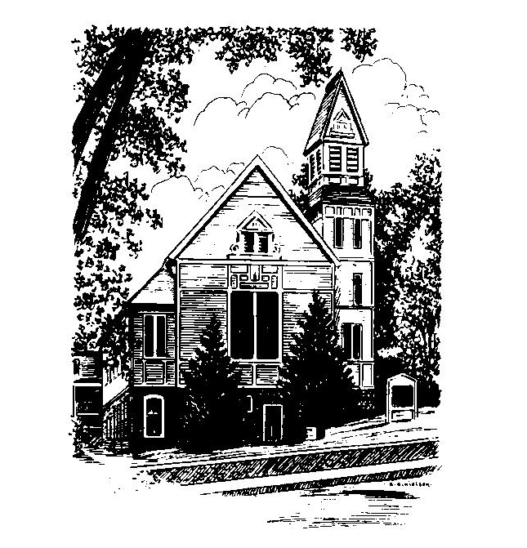
November 27, 2022
First Sunday of Advent

No Matter Who You Are,
No Matter Where You Are on Life’s Journey,
You Are Welcome Here!

WELCOME
Welcome to our first-time guests!
Welcome to those who have no church home, need strength, have doubt, want to follow Christ, or even do not believe. Welcome to those who have more questions than answers or aren't sure where they are on their journey of faith!
Welcome to those who were baptized here and have worshiped in this place for generations!
Welcome to people of all sexual orientations & gender identities, to people of all racial & ethnic heritages, and to families of every shape and size!
May God find you where you are
and welcome you home

PRELUDE:
(Please remember some will be in meditative silence during the prelude)

WELCOME & ANNOUNCEMENTS

CALL TO WORSHIP
One: It is the season of hope and the time of waiting.
All: We wait in hope knowing that the God of all time
has come to us.
One: Hope is not lost, nor waiting in vain for the Creator
redeems the world with love.
All: We gather here praying for God’s redemption to
be made alive in us, and for hope of God to be
made evident in our world.

0PENING HYMN: Lift Up your Heads
Red hymnal #129

Meditation Thought
Advent’s watchwords are preparation and waiting. It’s about looking outward and ahead. It’s a time for Christians to declare that God’s previous incursion into human affairs through Jesus Christ is not the end of the story but the foundation for a future hope of God bringing ultimate promises to fruition. The impulses behind Advent should alarm those who are overly enamored with the current system (who probably number more than 1%), as well as any others who are overly confident in their ability to engineer what’s best for the world.” -Matthew L. Skinner, Associate Professor of New Testament at Luther Seminary in Saint Paul, Min.

Please join us for coffee hour downstairs immediately after worship.

To Contact Us:
Church Office: 978-939-8821
Web Site: www.baldwinvillecongochurch.com
The Rev. Richard A. Jones, Minister
E-mail: Revraj@aol.com
Tel: 413- 283- 4440
Organist: Michelle Salvanelli
978-632-4901
Videographer: Jeff Salvanelli

Deacon for November: Lei Messer

Liturgist: Lei Messer

Calendar of Upcoming Events:
Today: Last Sunday to order poinsettias for Christmas Sunday (deadline=Mon. Dec.5)-sign up is in the back. Put order
in an envelope for Barbara
Christmas Sunday (Dec. 18): Bring bells to ring
Christmas Eve Service of Carols and Candles 5:00 PM

OPENING PRAYER:
O God, of Advent’s longing, come move among us, we pray, and help our limping imaginations wonder at the way your grace has touched our lives and your presence has come to our world. We seek to embrace something of your mystery in this time together: stir us, renew us, heal us and transform us, that our living may serve your purposes. Inspire us again, O God, with the hope of Advent that we too might stir the world with our faith and faithfulness. In Christ’s name, amen.

*SHARING THE PEACE OF CHRIST
One: May the peace of Christ be with you!
Many: And also with you!

*AMEN (Sung twice): Red Hymnal #317
Amen, Amen,
Amen, Amen, Amen.

LIGHTING OF THE ADVENT CANDLE
(words on back of bulletin) -Nancy & Bernie Heaney

CHORAL RESPONSE: -Light One Candle

OFFERING OURSELVES AND OUR GIFTS TO GOD:
“Lord Jesus Christ, today I offer my life to you.
Create a miracle in my life and in our church.”

You are invited to bring forward your offering while we sing together: +

Praise God, from whom all blessings flow;
Praise God, all creatures here below;
Alleluia! Alleluia!
Praise God above, you heavenly host;
Praise Father, Son, and Holy Ghost.
Alleluia! Alleluia! Alleluia!
Alleluia! Alleluia!
The tune with different words may be found in the Red Hymnal #22

*DEDICATION OF OUR OFFERING &
PLEDGES
O Holy One, who’s coming into our world is beheld through the eyes of faith, stir in us a deeper awareness of your grace and your spirit. We commit ourselves anew to be a church witnessing to your presence in our world. Bless and use all we give today and through the coming year to the greater service of your Christ. Amen

FIRST SCRIPTURE: Isaiah 2: 1 - 5

SPECIAL MUSIC

GOSPEL LESSON: Matthew 24: 36 -44

SERMON: “The Return”
HYMN: Creator of the Stars Red hymnal #127

SHARING OUR PRAYERS, OUR JOYS AND
SORROWS
PASTORAL PRAYER
THE LORD’S PRAYER
Our Father, who art in heaven, hallowed be thy name. Thy kingdom come. Thy will be done on earth as it is in heaven. Give us this day our daily bread. And forgive us our trespasses, as we forgive those who trespass against us. And lead us not into temptation, but deliver us from evil. For thine is the kingdom, and the power, and the glory, forever. Amen.
CHORAL PRAYER RESPONSE: #306 Red Hymnal
Hear our Prayer, O Lord, Hear our prayer O Lord.
Incline thine ear to us, and grant us thy peace.

*CLOSING HYMN: Come O long Expected Jesus
Red hymnal # 125
*SENDING FORTH:
One: May the God of Advent stir your hearts with hope and
love.
ALL: May God’s hope ever burn in our hearts and
guide our living.
One: May God give new strength to your dreams of a
world at peace with goodwill to all humankind.
All: We work and wait for a world of peace and justice
and seek God’s grace in all our lives.

POSTLUDE:

*Indicates all who are able please stand

