To Contact Us:
Church Office: 978-939-8821
Church website: www.baldwinvillecongochurch.org
Rev. Richard A. Jones -413-283-4440
Revraj@aol.com
Organist: Michelle Salvanelli
Videographer: Jeff Salvanelli
Church wi-fi password: Memorial 1874

Deacon of the Month: Lei Messer
Liturgist: Nowell Frances
ANNOUNCEMENTS:
Today: Coffee and conversation downstairs after church
We are now colleting canned goods & food for the Food Pantry
Next Sunday will be “Pledge Sunday” as we dedicate our pledges for 2023.
*denotes “All who are able please stand”.
Masking is optional for worship.
Meditation Thought
“A sense of reverence and awe in the Presence of God cannot be learned, cannot be taught. Without awe, people turn to doctrine. Without reverence, people turn to rules. Doctrine and rules can be taught and learned. ---Reverence and awe are born in the people’s hearts.” ---William Martin, The Art of Pastoring: Contemplative Reflections

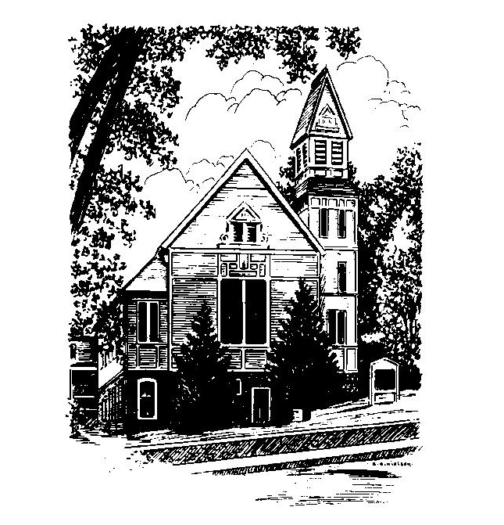
MEMORIAL CONGREGATIONAL CHURCH U.C.C. BALDWINVILLE, MA.
An Open and Affirming Church of
the United Church of Christ
November 20, 2022
Christ the King Sunday ~ Thanksgiving
No Matter Who You Are, No Matter Where
You Are on Life’s Journey, You Are Welcome Here!
PRELUDE:
WELCOME:
CALL TO WORSHIP:
One: Our pilgrim forefathers and mothers went with faith to a
new and unknown land.
ALL: The future is always an unknown land, but we travel
with God, who steadies our feet for the journey and
readies our hearts for the tasks.
One: It is the mystery of God that moves in every age to
awaken hope in people of faith and give birth to new vision..
ALL: We would be people of faith. We would be
enlivened by God’s Spirit and renewed by God’s
presence. Thanks be to God
*OPENING HYMN: Come O Thankful People, Come
Black hymnal # 356
OPENING PRAYER: (unison O Lord of harvests, we come to you now as we prepare for winter’s cold asking that you might steady us and strengthen us for whatever journeys yet lie ahead and whatever unknown waters there are that we may need to cross. Help us, to find in our faith, the power to live boldly and lovingly towards a future we do not yet know. Teach us your purposes and how we may better build the world of justice and caring Jesus called us to create. Empower us and renew us in this journey of faith. Amen.
*SHARING THE PEACE OF CHRIST
One: May the peace of Christ be with you!
Many: And also with you!
--Please “Pass the Peace” however you feel comfortable as we
sing Amen!
*AMEN (Sung twice) Red Hymnal #317
Amen, Amen, Amen, Amen, Amen
OFFERING OURSELVES AND OUR GIFTS TO GOD: --Our offering will be brought forward as we sing: ( If you have not put you offering in the offering plate you may do so now)
Praise God, from whom all blessings flow;
Praise God, all creatures here below;
Alleluia! Alleluia!
Praise God above, you heavenly host;
Praise Father, Son, and Holy Ghost.
Alleluia! Alleluia! Alleluia!
Alleluia! Alleluia!
The tune with different words may be found in the Red Hymnal #22
*DEDICATION: Remembering the richness and the fullness of our ancestor’s faith, O God, we dedicate anew our offerings to you and to the work of Christ. Help us to be worthy of the heritage we have received and to live your redeeming love and hope in the midst of our troubled world. Amen.
FIRST SCRIPTURE: Luke: 1: 68 -79
SPECIAL MUSIC:
SECOND SCRIPTURE: Luke 23: 26 - 46
SERMON: Christ the King
HYMN: Open My Eyes that I May See Black Hymnal # 419
SHARING OUR PRAYERS, OUR JOYS, OUR HOPES --PASTORAL PRAYER
THE LORD’S PRAYER : Our father who art in heaven hallowed be thy name. Thy kingdom come thy will be done on earth as it is in heaven. Give us this day our daily bread and forgive us our trespasses as we forgive those who trespass against us. And lead us not into temptation but deliver us from evil. For thine is the kingdom and the power and the glory forever. Amen.
-Response (sung)
Hear our Prayer, O Lord, Hear our prayer O Lord.
Incline thine ear to us, and grant us thy peace. Amen

*CLOSING HYMN: For the Fruit of All Creation
Black Hymnal # 425

*SENDING FORTH:
One: Go forth from this place thankful for the gifts of God.
ALL: We are thankful!
One: Go forth from this place assured of God’s love.
ALL: We are assured!
One: Go forth from this place and live the faith!
ALL: May God grant us strength to live the faith, in hope
and covenant together!

POSTLUDE

